Noisette potatoes
Complexity: low-medium

Ingredients

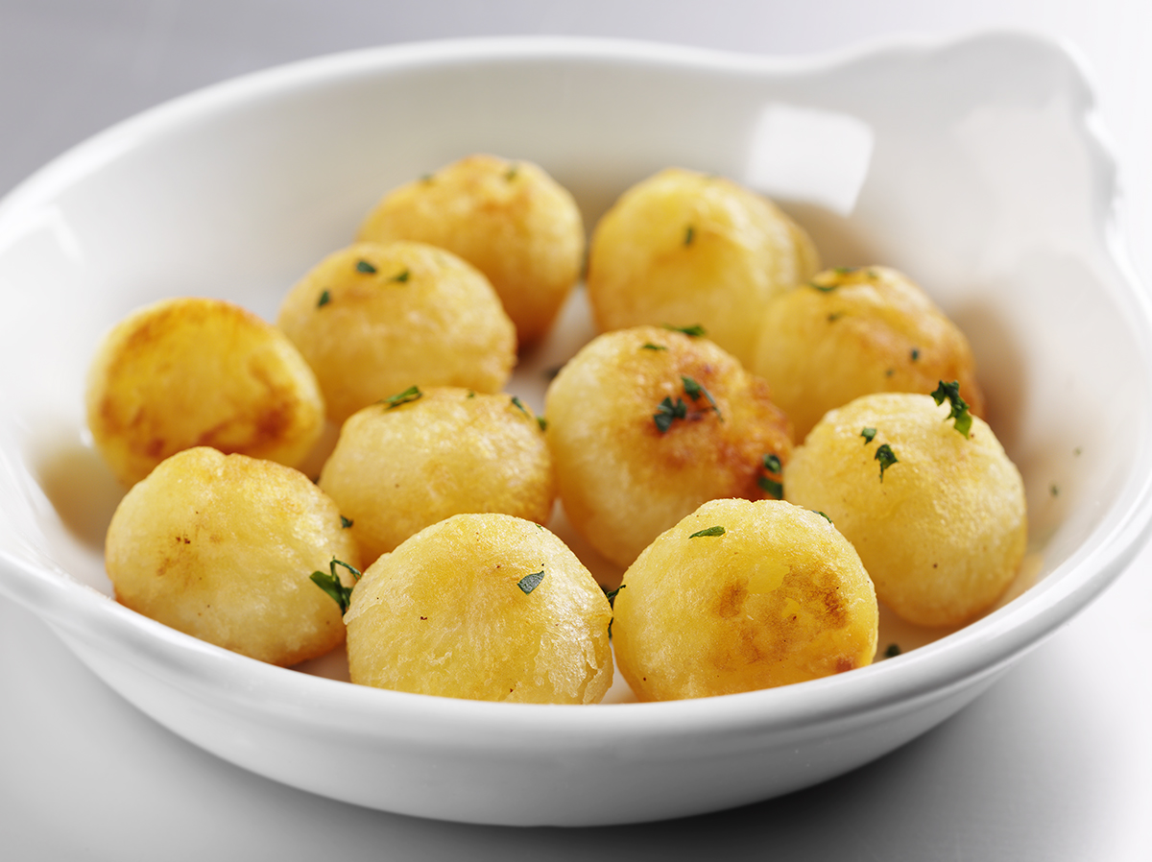
1kg of fluffy potatoes,
such as Maris Piper and King Edward

1 x 15ml spoon oil for frying

Equipment

Peeler, melon scoop, chopping board, saucepan, frying pan.

Method
- Pre-heat the oven to 230°C.
- Wash, peel and re-wash the potatoes.
- Scoop out balls with a melon scoop or ‘noisette spoon’.
- Blanch the potato balls in boiling water.
- Fry in a little oil in a sauté or frying pan to colour.
- Finish cooking in the oven.

Top tips
- Use spray oil for frying the potatoes.

Food skills
- Weigh.
- Measure.
- Peel.
- Boil.
- Fry.
- Bake.

