Parmentier potatoes

Ingredients
Complexity: medium

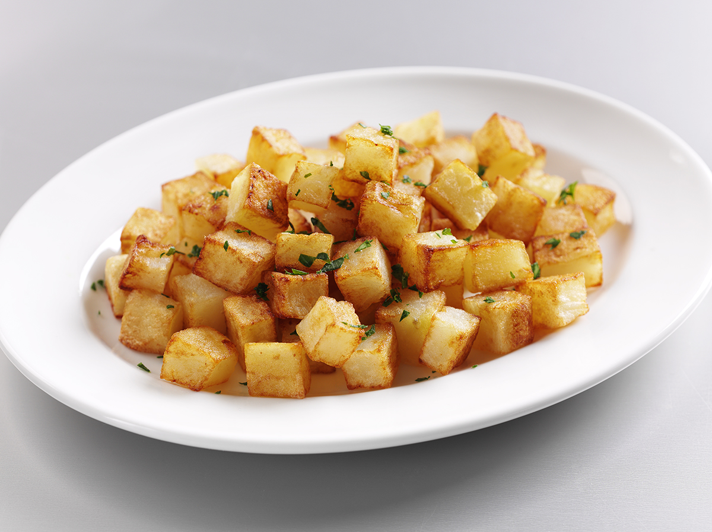
1kg of fluffy potatoes such as Maris Piper

and King Edward

Oil for frying

Pepper for seasoning

Equipment

Peeler, vegetable knife, chopping board, frying pan, heat resistant spoon.

Method
- Select medium to large potatoes.
- Wash, peel, re-wash.
- Trim on three sides and cut into 1cm slices.
- Cut the slices into 1cm strips.
- Cut the strips into 1cm dice.
- Wash well and dry with a paper towel.
- Cook in shallow oil in a frying pan until golden brown.
- Drain on kitchen paper, season lightly.

Top tips
- Sprinkle with chopped herbs such as parsley, dill or chives.

Food skills
- Weigh.
- Peel.
- Trim, cut and dice.
- Fry.

