Chateau potatoes
Complexity: low-medium

Ingredients

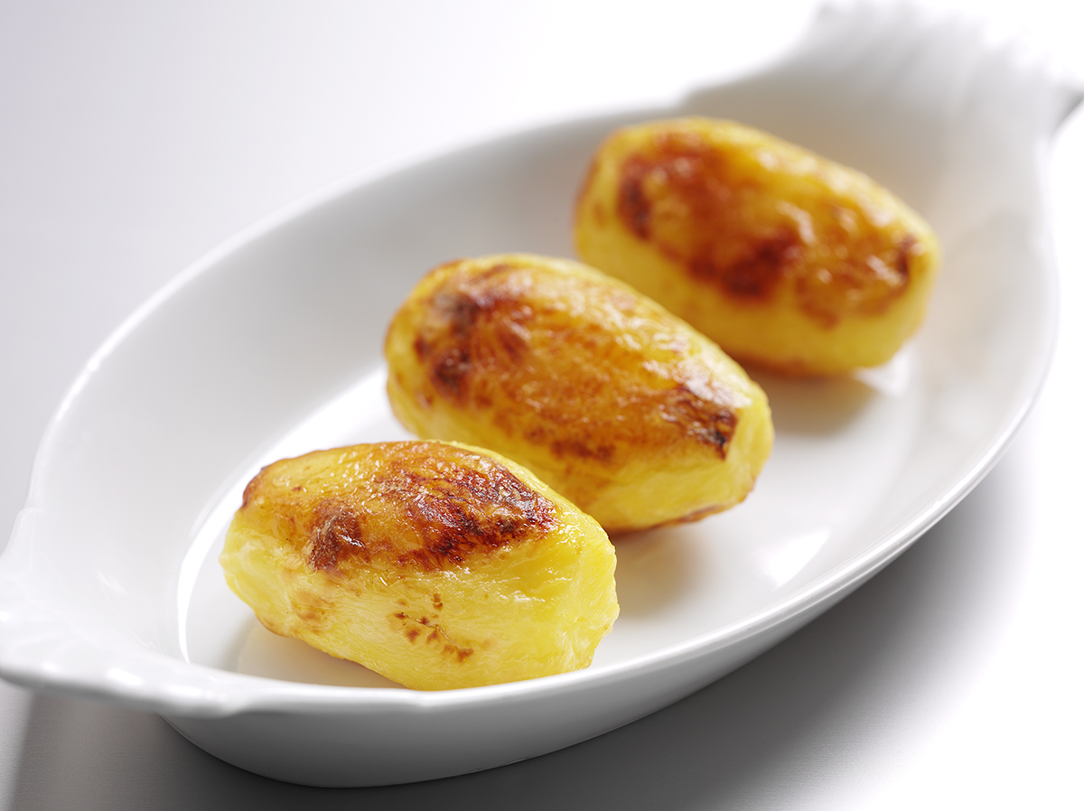
Salad potatoes such as Charlotte,
or smooth potatoes such as Desiree

Pepper for seasoning

Oil for greasing paper

Equipment

Peeler, vegetable knife, chopping board, saucepan, colander, greaseproof paper, fish slice.

Method
- Preheat the oven to 230-250°C.
- Choose small, even sized potatoes.
- Wash, peel and rewash the potatoes.
- Turn into 8-sided barrel shapes, about 5cm long and 2.5cm across in the centre, reducing to 1.5cm at each end.
- Prepare enough barrels for 2-3 per person and place in a saucepan of boiling water for 2-3 minutes.
- Refresh in cold water immediately and drain using a colander.
- Place the potatoes on lightly oiled greaseproof paper or a non-stick tray, season lightly with pepper and place in the oven for about 1 hour.
- Turn the potatoes after about half an hour and cook till golden brown.

Top tips
- Use spray oil for greasing the paper.
- Why not try spray oil flavoured with garlic or herbs.

Food skills
- Peel.
- Cut.
- Boil and simmer.
- Bake.

