Fibre-boosted Bolognese
Introduction
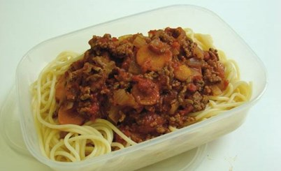
In this activity, you’ll be using nutritional analysis to find out the fibre content of a basic Bolognese recipe. Then you will suggest different ways to boost the fibre content of the dish.

The task:
- Go to Explore Food http://explorefood.foodafactoflife.org.uk/

- Analyse the basic Bolognese recipe by inputting each
of the ingredients listed on the right, in the correct
quantities. When you’ve entered your ingredients,
click ‘view summary’, input the number of portions for
the recipe and click ‘calculate’.
Basic Bolognese
Serves 3

Ingredients
1 onion (150g)
1 clove garlic (5g)
1 x 15ml spoon oil
250g lean minced beef
1 can chopped tomatoes (400g)
1 x 15ml spoon tomato purée
100ml water
1 x 5ml spoon mixed herbs
Black pepper
200g dried spaghetti

- Print the results.

- Review how much fibre the dish provides per portion.
Your goal is to increase the amount of fibre provided,
by replacing or adding ingredients.

- Analyse your modified recipe and print the results.

- Compare your two printouts and evaluate
your success.

- Describe the changes that you made and give your reasons. Remember, the recipe needs to be familiar and taste good!

