Boulangere potatoes
Complexity: medium

Ingredients

400g of smooth potatoes, such as Desiree

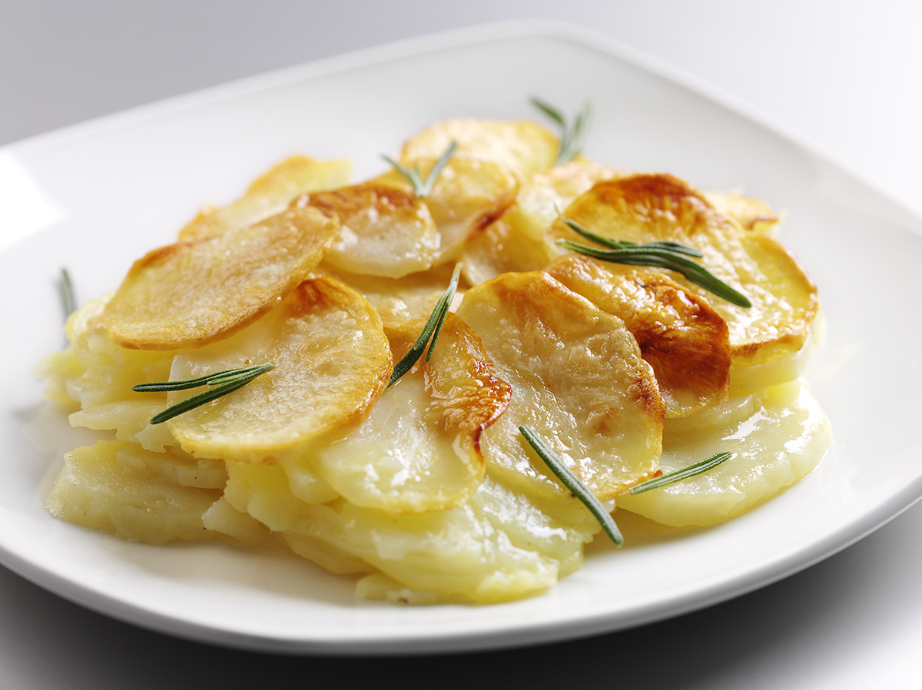
2 medium onions

Pepper

125ml chicken or vegetable stock

25g butter or soft spread

Fresh rosemary

Equipment
Vegetable knife, chopping board, peeler, mixing bowl, mixing spoon, roasting tin, pastry brush, flat bottomed pan.

Method
- Preheat the oven to 230°C.
- Cut the potatoes into 2mm slices with a vegetable knife or on a mandolin. Set aside enough slices to cover the top.
- Peel, halve and finely slice the onions.
- Mix the onions and potatoes and lightly season with salt and pepper.
- Place in a buttered roasting tin and cover with the stock.
- Neatly arrange the remaining potatoes by neatly overlapping the slices.
- Brush with oil or dab with butter/spread.
- Place in oven for 20 minutes until lightly coloured.
- Reduce the heat and allow to cook steadily. Press the potatoes down firmly, from time to time, using a clean flat-bottomed pan.
- Cook for approximately 1.5 hours in total, until all of the stock has cooked into the potato.

Top tips
- Serve sprinkled with rosemary leaves.

Food skills
- Weigh.
- Measure.
- Cut and slice.
- Peel.
- Crush.
- Arrange.
- Glaze.
- Bake.

