Delmonico potatoes
Complexity: low-medium

Ingredients

Fluffy potatoes such as Maris Piper and King Edward

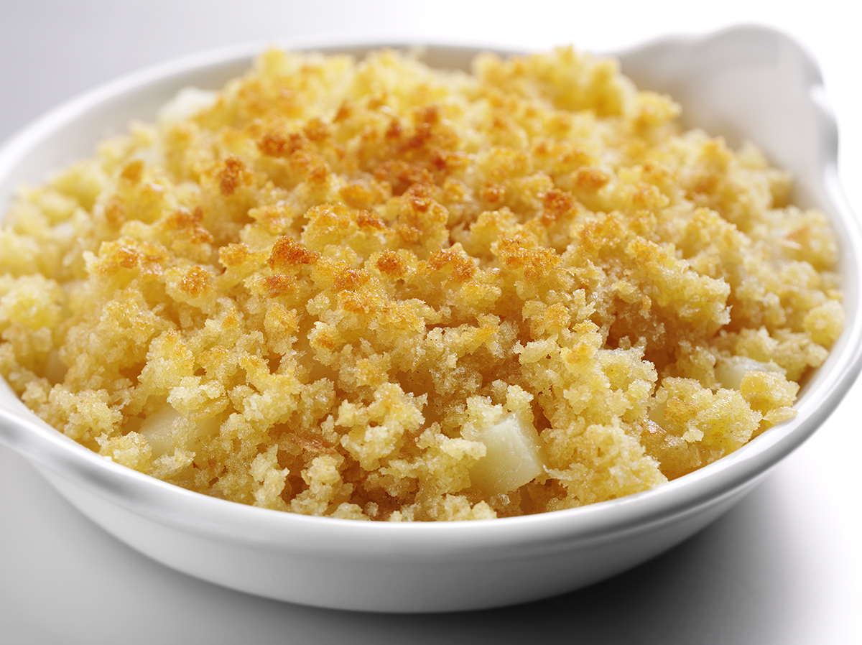
100ml whole milk

50g breadcrumbs

25g butter or soft spread

Pepper for seasoning

Equipment

Peeler, vegetable knife, chopping board, large saucepan, oven-proof dish.

Method
- Wash, peel and re-wash the potatoes.
- Cut into 6mm dice and place in a saucepan.
- Barely cover with milk, season lightly and allow to cook for 30-40 minutes.
- Melt the fat gently in a saucepan or the microwave.
- Place in an oven-proof dish, sprinkle with breadcrumbs and melted fat.
- Brown in the oven or under a grill and serve.

Top tips
- Use semi-skimmed milk and reduced fat spread to reduce the fat content of the dish.
- Use wholemeal breadcrumbs for added fibre.

Food skills
- Weigh.
- Measure.
- Peel.
- Cut and dice.
- Melt.
- Simmer.
- Grill or bake.

