Pommes Anna
Complexity: medium

Ingredients

1kg of salad potatoes, such as Charlotte

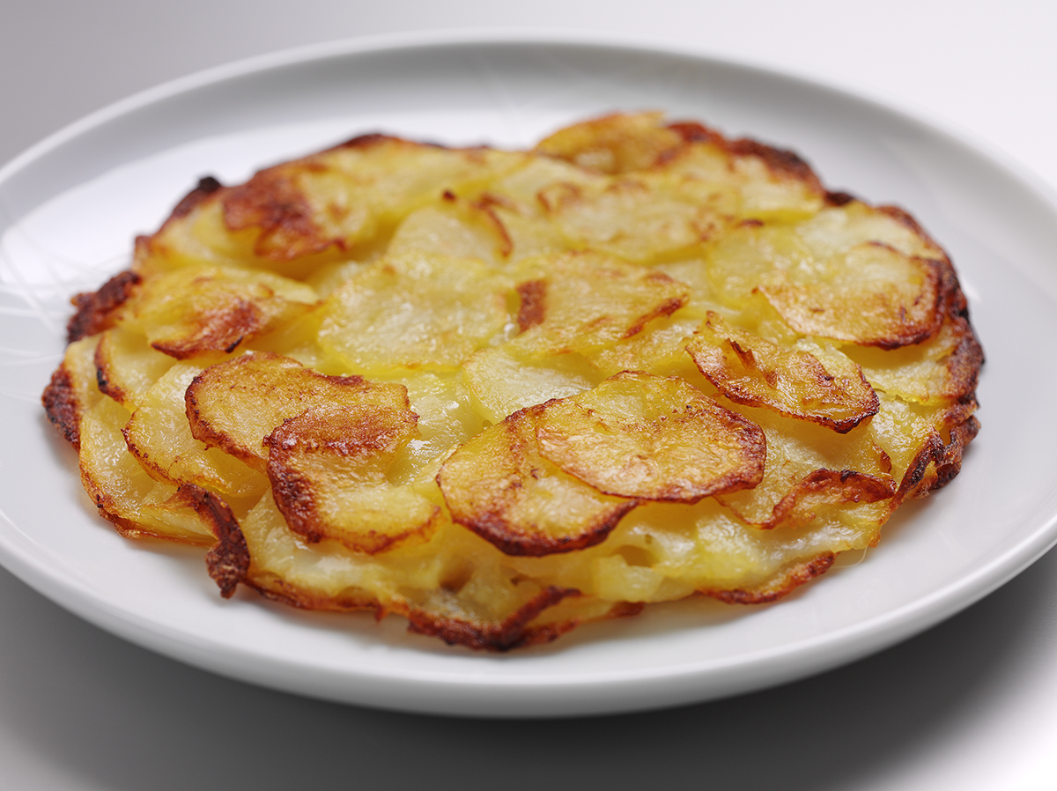
75g butter or soft spread

Freshly ground pepper

Equipment

Vegetable knife, chopping board, skillet or heavy based baking tin, large plate, fish slice.

Method
- Preheat the oven to 220°C.
- Slice peeled, washed potatoes into rounds as thin as possible (1mm if using a mandolin).
- Grease a 15cm diameter skillet or heavy based baking tin and arrange a thin layer of potatoes over the base – overlapping slices.
- Drizzle a little melted butter or spread over the slices and season with pepper.
- Continue to layer potatoes, drizzle butter or spread and season until you have used all the potatoes.
- Drizzle over the remaining butter or spread and place in the preheated oven.
- Cook for 40-50 minutes or until very tender and the potatoes are golden on the bottom and crisp on the outside.
- Press down the potato slices 3 or 4 times during cooking to form a solid cake and reserve any excess butter.
- Half way through cooking, shake the pan back and forth to stop the potatoes from sticking, and flip the potatoes over onto a lid or large plate. Add the reserved butter or spread to the pan and slide the potatoes back into the dish to finish cooking.
- Slice into wedges for serving.

Top tips
- Try reduced fat spread or spray oil to reduce the fat content of the dish.

Food skills
- Weigh.
- Slice.
- Arrange.
- Bake.

