Macaire potatoes (potato cakes)

Ingredients
Complexity: medium

1kg of fluffy potatoes such as Maris Piper

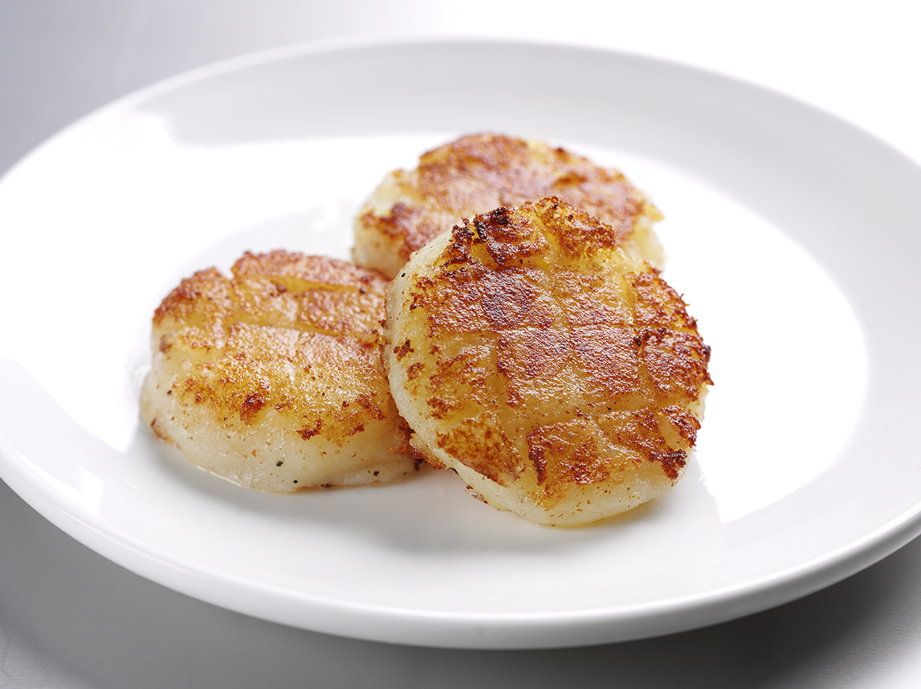
and King Edward

50g butter or soft spread

A little flour for coating

Pepper for seasoning

Oil for frying

Equipment
Vegetable knife, chopping board, baking tray, spoon, large mixing bowl, fork, palette knife, frying pan.

Method
- Preheat the oven to 230-250°C.
- Select good-sized potatoes (1 per portion), scrub well and make a 2mm deep incision round the potato.
- Place the potatoes on a baking tray.
- Bake in the oven for around 1 hour, turning after 30 minutes.
- Test by holding the potato in a clean cloth and squeezing gently. They are ready when they feel soft.
- When cool, cut in half and scoop out the centre.
- Place in a bowl with the fat and a little pepper.
- Mash and mix as lightly as possible with a fork.
- Using a little flour mould into a roll and then divide into pieces.
- Mould into 2cm round cakes. Quadrille with the back of a palette knife and flour lightly.
- Shallow fry on both sides and serve.

Top tips
- Use spray oil for frying.

Food skills
- Weigh.
- Cut.
- Mash.
- Mix.
- Form and shape.
- Fry

