Garlic bread
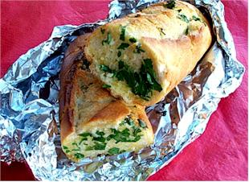
Ingredients
1 small wholemeal baguette
Complexity: low-medium
50g butter or soft spread
2 cloves of garlic
15ml spoon fresh parsley

Equipment
Garlic press, chopping board, sharp knife, small bowl, mixing spoon, bread knife, spreading knife, foil.

Method
- Preheat oven to 200ºC, gas mark 6.
- Peel and crush the garlic.
- Chop the fresh parsley.
- Mix the fat, garlic and parsley together in a small bowl.
- Cut the baguette into slices.
- Spread the garlic butter onto each slice.
- Wrap the baguette in foil.
- Place in the oven and bake for 10 minutes.
- Peel foil back and bake for a further 5 minutes until crunchy.

Top tips
- Use a plant based spread (such as olive oil or sunflower spread) - it is lower in saturated fat than butter.
- Try wraps, rolls, naan or pitta bread for a change.
- Bread can be kept in the freezer to keep it fresh for longer.

Food skills
- Weigh.
- Measure.
- Peel.
- Crush.
- Chop and cut.
- Spread.
- Bake.

