Fruity flapjacks
Ingredients
Complexity: low-medium
2x15ml spoons golden syrup
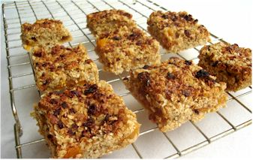
50g butter or soft spread
50g sugar
150g oats
50g dried fruit, e.g. sliced apricots

Equipment
Baking tray, measuring spoons, saucepan, wooden spoon.

Method
- Preheat oven to 200C or gas mark 6.
- Grease a shallow baking tin and line with greaseproof paper.
- Place the syrup, fat and sugar into a saucepan and gently heat until the spread has melted.
- Remove from the heat and stir in the oats.
- Pour ½ the mixture into the baking tin.
- Arrange the dried fruit over the mixture.
- Pour the remaining mixture over the fruit and pat down.
- Bake for 20 minutes until lightly browned.
- Remove from the oven and cut into portions in the baking tray while hot.

Top tips
- Vary the type of dried fruit, e.g. sultanas, figs, mixed fruit.
- Add 1x5ml spoon cinnamon or mixed spice to the oat mixture.
- Try using a little less sugar (or replace some with sweetener) and a little more dried fruit in the flapjacks to make them healthier.

Food skills
- Weigh.
- Measure.
- Melt.
- Stir.
- Bake.
- Cut.
- Portion.

