Cauliflower cheese
Ingredients
Complexity: medium
1 cauliflower
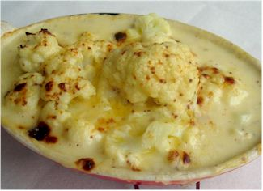
75g reduced fat Cheddar cheese
25g butter or soft spread
25g plain flour
250ml semi-skimmed milk
1x5ml spoon mustard

Equipment
Chopping board, knife, two saucepans, grater, measuring jug, measuring spoons, colander, heat proof dish.

Method
- Remove the green leaves and stalk from the cauliflower and cut into small florets.
- Place the florets into a saucepan of boiling water. Simmer for 5-6 minutes.
- Grate the cheese.
- Make the sauce:
- melt 25g fat in a saucepan;
- stir in 25g plain flour;
- mix the flour and butter together to form a paste;
- gradually add 250ml milk, stirring constantly as it thickens. Simmer for 2 minutes;
- add 50g of cheese and the mustard to the sauce.
- Drain the cauliflower and place it in a heat proof dish.
- Pour the cheese sauce over the cauliflower.
- Sprinkle the remaining cheese over the top.
- Place under a hot grill until golden brown.
- Serve.

Top Tips
- Make up the sauce and pour over fish, pasta or other vegetables.
- Exchange the cauliflower for a range of cooked vegetables for a terrific veggie bake.
- Stir the sauce with cooked pasta, canned tuna, sweetcorn and spring onion for a quick ‘tuna pasta bake’.
- Try using 1% or skimmed milk and reduced fat cheese to make it healthier.

Food skills
- Weigh.
- Measure.
- Boil and simmer.
- Grate.
- Melt.
- Mix and stir.
- Drain.
- Grill.

