Cheesy scones

Ingredients
Complexity: medium
250g self raising flour
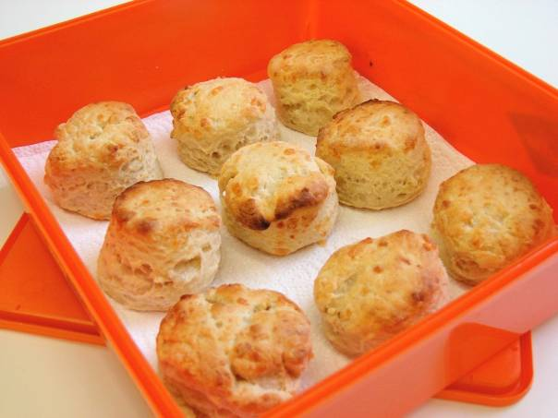
1 x 5ml spoon mustard powder
40g butter or baking fat/block
75g hard cheese
125ml semi-skimmed milk

Equipment
Non-stick baking tray, pastry brush, weighing scales, sieve, mixing bowl, measuring spoons, grater, chopping board, measuring jug, flour dredger, rolling pin, scone cutter, cooling rack.

Method
- Preheat oven to 220°C or gas mark 7.
- Grease or line the baking tray.
- Sift the flour and mustard into the bowl.
- Rub the fat into the flour until it resembles breadcrumbs.
- Grate the cheese.
- Stir in the cheese.
- Make a well in the middle of the flour and carefully pour in the milk. (Save just a little of the milk).
- Mix to form a soft dough.
- Place the dough on a lightly floured work surface.
- Roll out the dough to about 1½cm thick.
- Shape the scones using a cutter.
- Place the scones on a baking tray and brush each top with a little milk.
- Bake for 12 – 15 minutes, until golden brown.
- Allow to cool on a cooling rack.

Top tips
- To make fruit scones, add 25g sugar and 75g currants or sultanas before the milk and leave out the cheese.
- Traditionally, fluted scone cutters are used for sweet scones and plain cutters for savoury scones.
- You could experiment with different flavourings by adding herbs or spices.

Food skills
- Weigh.
- Measure.
- Sift.
- Grate.
- Mix and stir.
- Rub in.
- Roll out.
- Form and shape.
- Bake.

This recipe is from the original Licence to Cook programme and is provided under the Open Government Licence.

