Quick pizza

Ingredients
Complexity: low-medium
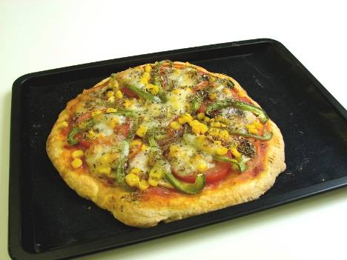
150g self-raising flour
40g butter or baking fat/block
100ml milk

Topping
50g hard cheese or mozzarella cheese
3 x 15ml spoon tomato pizza sauce, passata or canned tomatoes
2 slices ham
Plus a selection of the following: green or red pepper, mushrooms, onion, pineapple, sweetcorn, cherry tomatoes

Equipment
Grater, vegetable knife, chopping board, sieve, mixing bowl, table knife, measuring spoon, 17cm Victoria sandwich tin, round tin foil dish or baking tray.

Method
- Pre-heat oven to gas mark 6 or 200°C.
- Grease the baking tin or line with greaseproof paper.
- Prepare ingredients:
  - grate the cheese;
  - slice or tear ham into small pieces;
  - deseed, slice or dice the vegetables and halve the cherry tomatoes.
- Sift the flour into a mixing bowl. Cut the fat into small pieces using a table knife and add to the flour.
- Rub the fat into flour until it resembles breadcrumbs.
- Add milk a spoonful at a time and stir.
- Mix to a soft dough and knead lightly until smooth.
- Press the dough into tin using knuckles or roll into a circle and place on baking tray.
- Spread the tomato sauce over the base. If using canned tomatoes, drain well.
- Add toppings and spread evenly.
- Cover with the grated cheese making sure the tomato sauce is well covered.
- Bake in the oven for 20-25 minutes until the base is cooked.

Top tips
- Use wholemeal flour for extra fibre.
- Use skimmed milk and reduced fat or lighter cheese to reduce saturated fat content.
- Cover the pizza with aluminium foil, label and refrigerate. Cook at home.

Food skills
- Weigh.
- Measure.
- Bake.
- Grate.
- Slice and dice.
- Sift.
- Rub-in.
- Mix.
- Knead.
- Form and shape.
- Spread.

