Banana crumble-top muffins
Complexity: medium

Ingredients

1 lemon

115g butter or soft baking spread

2 medium eggs

225g self-raising flour

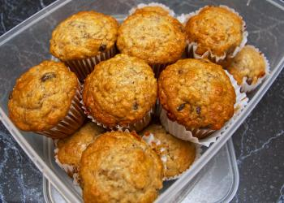
1 x 5ml spoon (level) baking powder

1 x 5ml spoon ground cinnamon

85g caster sugar

2 medium ripe bananas

175ml semi-skimmed milk

For the crumb topping:

15g butter or hard baking fat

25g plain flour

pinch of ground cinnamon

15g demerara sugar

Equipment
Mixing bowl, wooden spoon, fork, measuring jug, measuring spoons, small grater, muffin tray, muffin cases, cooling rack, oven gloves.

Method
- Pre-heat the oven to 200°C/gas mark 6.
- Zest the lemon.
- Melt the fat gently in a saucepan or the microwave.
- Beat the eggs.
- Sift the flour, baking powder and cinnamon together into a large bowl. Stir in the sugar and lemon zest.
- Mash the bananas together until smooth then stir into the flour mixture with the melted fat.
- Add the milk and beaten eggs to the bowl and stir until just mixed together. Do not over mix as this will make the muffins 'heavy'.
- Line a 12-hole large muffin tray with paper muffin cases. Divide the mixture between the holes. If there is extra mixture, use another tray.
- In a small bowl, rub the remaining butter or baking fat, flour and cinnamon together until the mixture resembles fine breadcrumbs. Stir in the demerara sugar.
- Sprinkle the breadcrumb mixture over the top of the muffins and cook them in the preheated oven for 20–25 minutes or until well risen and firm to the touch.
- Remove the tray from the oven and leave the muffins to cool in the tray for at least 5 minutes. Then transfer the muffins to a cooling rack to cool completely.

Top tips
- Add crushed walnuts for a bit of crunch.
- Add sultanas or raisins.
Food skills
- Weigh.
- Measure.
- Zest.
- Melt.
- Beat.
- Sift.
- Stir.
- Mash.
- Divide.
- Rub in.
- Bake.

