Apple muffins
Complexity: medium

Ingredients

125g self-raising flour

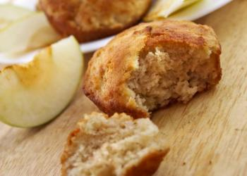
50g wholemeal flour

15ml spoon (level) baking powder

5ml spoon ground cinnamon

75g golden granulated sugar

100g oats

2 apples

2 medium eggs

200ml semi-skimmed milk

75g butter or soft baking spread

2 large ripe bananas

½x 5ml spoon demerara sugar

Equipment
Measuring scales, sieve, measuring spoons, small vegetable knife, chopping board, small jug, paper muffin cases, spatula, oven, timer.

Method
- Heat the oven to 200°C/gas mark 6. Place deep paper cases in a muffin tin.
- Sift the flours, baking powder and cinnamon into a bowl. Add the sugar and oats, reserving 15ml spoon of oats.
- Peel, core and chop the apples and add to the dry ingredients and mix.
- Beat the eggs and milk together in a small jug (wet ingredients).
- Peel, chop and mash the banana and add to the wet ingredients.
- Gently melt the fat in a saucepan or the microwave and add to the wet ingredients.
- Pour the combined wet ingredients into the bowl of dry ingredients.
- Fold together until combined. Do not over mix or the muffins will be 'heavy'.
- Spoon the mixture into the paper cases.
- Mix the demerara sugar with the reserved oats and sprinkle over each muffin.
- Bake in the oven for 15–20 minutes, until golden and firm.

Top tips
- Replace the apples with blueberries, walnuts or cranberries and make a different muffin every day.

Food skills
- Weigh.
- Measure.
- Sift.
- Peel.
- Core.
- Chop.
- Beat.
- Mash.
- Melt.
- Stir.
- Mix.
- Bake.

