Parkin
Complexity: medium

Ingredients

150g dark syrup

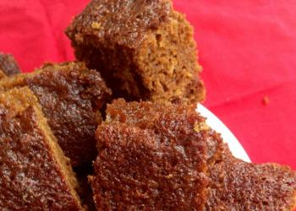
75g butter or soft baking spread

75g soft brown sugar

175g medium oatmeal

75g self-raising flour

1.5 x 15ml spoons ground ginger

1 small egg

1 x 10ml spoon milk

50g dates

50g sultanas

Equipment
measuring scales, 15cm/6 inch square cake tin, saucepan, measuring spoons, wooden spoon, sieve, chopping board, knife, large mixing bowl, small mixing bowl, fork, measuring jug, cooling tray.

Method
- Pre-heat oven to 140°C or gas mark 1.
- Lightly grease or line the cake tin.
- Place the syrup, fat and sugar into a saucepan and gently heat until the fat has melted. Do not boil.
- Sift the flour into the mixing bowl and add the oatmeal and ginger.
- Chop the dates and add to the bowl with the sultanas.
- Gradually stir in the warmed syrup mixture until everything is thoroughly blended.
- Beat the egg and add along with the milk.
- Pour the mixture into the prepared tin and bake in the centre of the oven for about 1 hour or until the centre feels springy to the touch.
- Cool for 5 minutes before turning out.

Top tips
- This can be cooked in smaller tins or fairy cake tins to reduce cooking time.

Food skills
- Weigh.
- Measure.
- Melt.
- Stir.
- Sift.
- Chop.
- Bake.

