Pastry: basic shortcrust
Complexity: low

Ingredients

110g plain flour

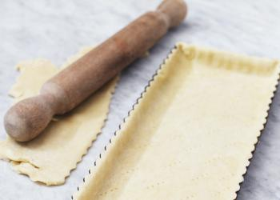
25g lard

25g butter or baking fat/block

1 x 15ml cold water

Equipment
Measuring scales, sieve, large mixing bowl, butter knife, measuring spoons, polythene bag.

Method
- Begin by sifting the flour into a large bowl, holding the sieve above the bowl so that the air gets a really good airing before you begin.
- Chop the fat into smallish lumps add to the flour then take a knife and begin to cut the fat into the flour. Go on doing this until it looks fairly evenly blended, then begin to rub the fat into the flour using your fingertips only and being as light as possible. As you gently rub the fat into the flour, lift it up high and let it fall back into the bowl, which again means that all the time air is being incorporated, but do this just long enough to make the mixture crumbly with a few odd lumps here and there.
- Sprinkle in 1 x 15ml water then start bringing the dough together, using the knife to make it cling.
- Discard the knife and, finally, bring it together with your fingertips. When enough liquid is added, the pastry should leave the bowl fairly clean. If this hasn't happened, then add a little more water.
- Now place the pastry in a polythene bag and leave it in the refrigerator for 30 minutes to rest.

Top tips
- Instead of a mixture of lard and butter, use baking fat/block only to reduce the saturated fat content of the pastry.
- Use baking fat/block for a pastry that is suitable for those that don’t eat animal products.

Food skills
- Weigh.
- Measure.
- Sift.
- Chop.
- Rub in.
- Mix.

