Savoury filled choux buns
Complexity: medium

Ingredients

60g strong white flour

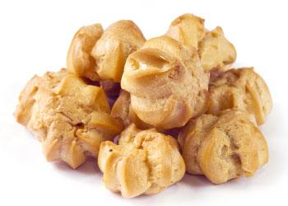
Pinch of mustard powder

Pinch of cayenne pepper

2 eggs (large)

50g butter or baking fat/block

150ml water

25g parmesan cheese

Twist of black pepper

100g cream cheese

2 slices of ham

1 tomato

Equipment
Baking tray, pastry brush, weighing scales, sieve, greaseproof paper, 2 small bowls, fork, measuring jug, saucepan, wooden spoon, 2 x 10ml spoons, knife, chopping board, cooling rack.

Method
- Preheat the oven to 200°C or gas mark 6.
- Grease or line the baking tray, and sprinkle a little water on top.
- Sift the flour, mustard powder and cayenne pepper onto the piece of greaseproof paper.
- Beat the eggs in the small bowl with the fork.
- Melt the fat in the water in the saucepan.
- When it starts to boil, remove from the heat and shoot in the flour.
- Beat the mixture briskly until it is smooth and leaves the side of the pan.
- Stir in the egg, a little at a time, to form a smooth paste.
- Grate the cheese
- Add the cheese and black pepper to the mixture and mix until combined.
- Place small spoons of choux pastry onto the baking tray.
- Bake for 10 minutes. Increase heat to 220 °C, gas mark 7, and bake for 15 minutes.
- Slice with the knife and place on the cooling rack.
- Chop the ham and dice the tomato, and mix with the cream cheese in the small bowl.
- When the buns are cool, fill with the cream cheese mixture.

Top tips
- Use a heat proof stand to place the saucepan on when stirring in the flour and egg.
- You can vary the flavours of the choux buns by adding salmon or smoked mackerel pate for example.

Food skills
- Weigh.
- Measure.
- Sift.
- Beat.
- Melt.
- Stir.
- Grate.
- Bake.

