Potato and spring onion cakes
Complexity: medium

Ingredients

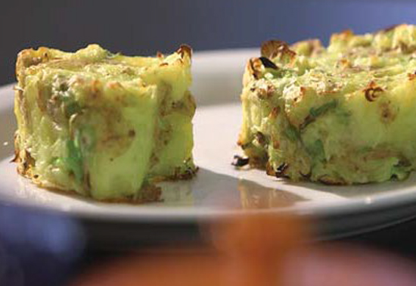
500g ‘Salad’ variety
(Charlotte, Maris Peer and Anya are all good for this)

2 -3 medium sized spring onions or a small bunch of chives

1 x 5ml spoon butter or soft spread

Freshly ground black pepper

Equipment
Vegetable knife, chopping board, large saucepan with lid, colander, fork, wooden spoon, 9cm ring mould, baking tray, oven gloves.

Method
- Pre-heat the oven to 180C.
- Start by washing the potatoes under cold running water to remove any dirt, but no need to peel these, the skin is where a lot of the flavour is.
- Cut the potatoes in half, and place in a saucepan to boil with just enough cold water to cover them, allow fifteen minutes for them to cook. Test them with a small knife, and once they are soft drain well in a colander.
- Place the potatoes back in the pan and dry them out on the hob for a further thirty seconds. With the side of a fork, break them up slightly. You don’t want to mash these; they just want to look like very lumpy mashed potato.
- Cut or snip the spring onions/chives.
- Now fold in the butter or soft spread, spring onion and pepper to taste.
- While still warm, press this mix into a ring mould of your choice, e.g. a 9 cm ring, about 2 cm deep. Remove the ring and repeat this until all the potato has been used.
- Place the potato cakes in the oven for 10 – 15 minutes to crisp up the outer edges.

Top tips
- Enjoy with a poached egg and mixed vegetables or a side salad.

Food skills
- Measure.
- Cut.
- Boil and simmer.
- Snip.
- Fold
- Form and shape.
- Bake.

