Croquette potatoes
Complexity: medium

Ingredients

600g smooth potatoes such as Desiree

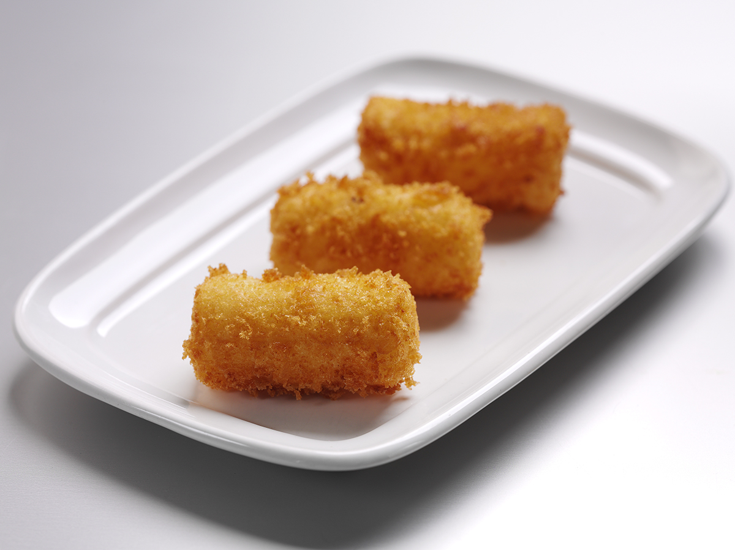
2 eggs

25g butter or soft spread

50g plain flour

100g fresh breadcrumbs

Pepper for seasoning

Equipment
Peeler, vegetable knife, chopping board, saucepan x 2, colander, potato ricer, mouli or sieve, mixing spoon, palette knife, deep fat fryer, kitchen paper.

Method
- Prepare a ‘Duchess’ mixture:
  - wash, peel and rewash potatoes and cut to an even size;
  - add potatoes to a pan of cold water, bring to the boil and cook;
  - drain, cover and return the potatoes to the pan, over a low heat, to dry out;
  - pass the potatoes through a potato ricer, mouli or sieve;
  - place the potatoes in a clean pan;
  - crack one egg and separate;
  - add the egg yolk to the potatoes and stir vigorously with a mixing spoon;
  - mix in the fat and season.
- Mould the mixture into cylinder shapes, approximately 5cm x 2cm.
- Crack the remaining egg and beat with a fork.
- Pass the potato shapes through flour, egg wash and breadcrumbs.
- Reshape with a palette knife and leave to chill.
- Deep fry in hot oil (185°C) in a frying basket.
- When the potatoes are a golden colour, drain well on kitchen paper and serve.

Top tips
- Ensure that the fat in the fryer is clean.
- Use long tongs or a frying basket to add or remove food.
- Carefully add food to avoid splashing.
- Do not overfill the fryer. Overfilling causes splashing and bubbling over of hot food.

Food skills
- Weigh.
- Peel.
- Cut.
- Boil and simmer.
- Form and shape.
- Fry.

