Peasy cheesy canapés
Ingredients
Complexity: medium
1 x bagel, halved, toasted and cut into eight pieces
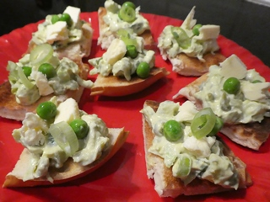
50g peas, canned or frozen and defrosted
16 x peas (for decoration)
½ lime
1 x spring onion, washed and trimmed
3 x mint leaves, washed
50g reduced fat soft cheese
1 x thin slice of crumbly cheese
(e.g. Cheshire, Lancashire)

Equipment
Juicer, small mixing bowl, fork, kitchen scissors, 10ml spoon, mixing spoon, chopping board, 2 x small spoons, serving plate.

Method
- Juice the lime.
- Place the peas into the bowl and crush with the fork.
- Snip the spring onion, finely, into the bowl (put aside the first eight snips for decoration at the end).
- Snip the mint leaves into the bowl.
- Add the reduced fat soft cheese.
- Add 10ml of the lime juice.
- Mix all the ingredients together.
- Place the bagel pieces onto the chopping board.
- Spoon the mixture equally onto the eight pieces of bagel.
- Crumble the slice of cheese onto the chopping board and add a few pieces to each bagel.
- Decorate the bagel pieces with the 16 saved peas and the snips of spring onion put aside earlier.
- Arrange on a serving plate.

Top tips
- Try wholegrain bagels or other types of toasted bread.
- Use cottage cheese instead of soft cheese.
- Try adding other ingredients to your mixture, e.g. chives, cooked ham.
- Top each canapé with a small mint leaf.
- Serve with pepper sticks or halved cherry tomatoes

Food skills
- Grill.
- Juice.
- Top and tail, trim and cut.
- Mix.
- Decorate.

