Stripy salad pots
Ingredients
Complexity: low-medium
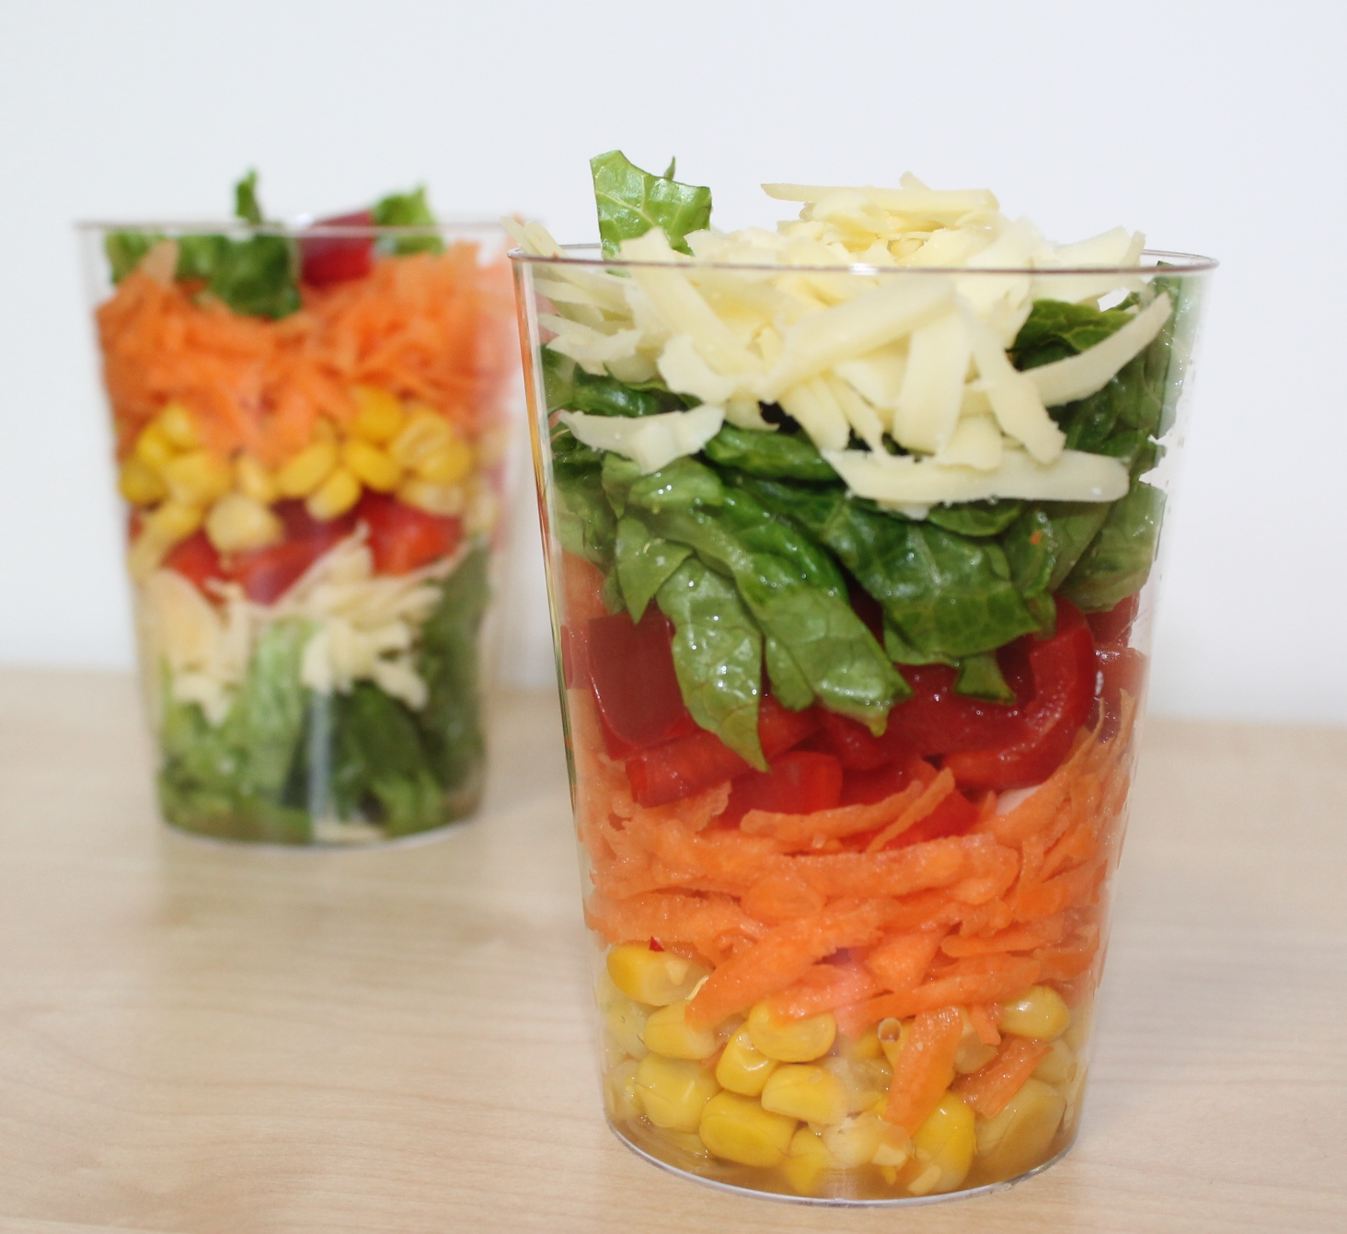
30g Cheddar cheese
1 small carrot
1/2 red pepper, deseeded
2 x lettuce leaves
4 x 15ml spoons sweetcorn

Equipment
Chopping board, grater, plate, vegetable knife, peeler, kitchen scissors, 2 clear plastic cups.

Method
- Grate the cheese.
- Top, tail, peel and grate the carrot.
- Snip the pepper into strips and then into small pieces.
- Cut the lettuce leaves into thin strips.
- Arrange the ingredients in layers in the cup.

Top tips
You could add other ingredients to your salad pot:
- chopped cherry tomatoes, grapes or olives;
- grated courgette;
- canned tuna;
- cooked prawns;
- sliced ham or chicken.

Food skills
- Grate.
- Cut and slice.
- Snip.
- Arrange.

