Apple and sultana crumble
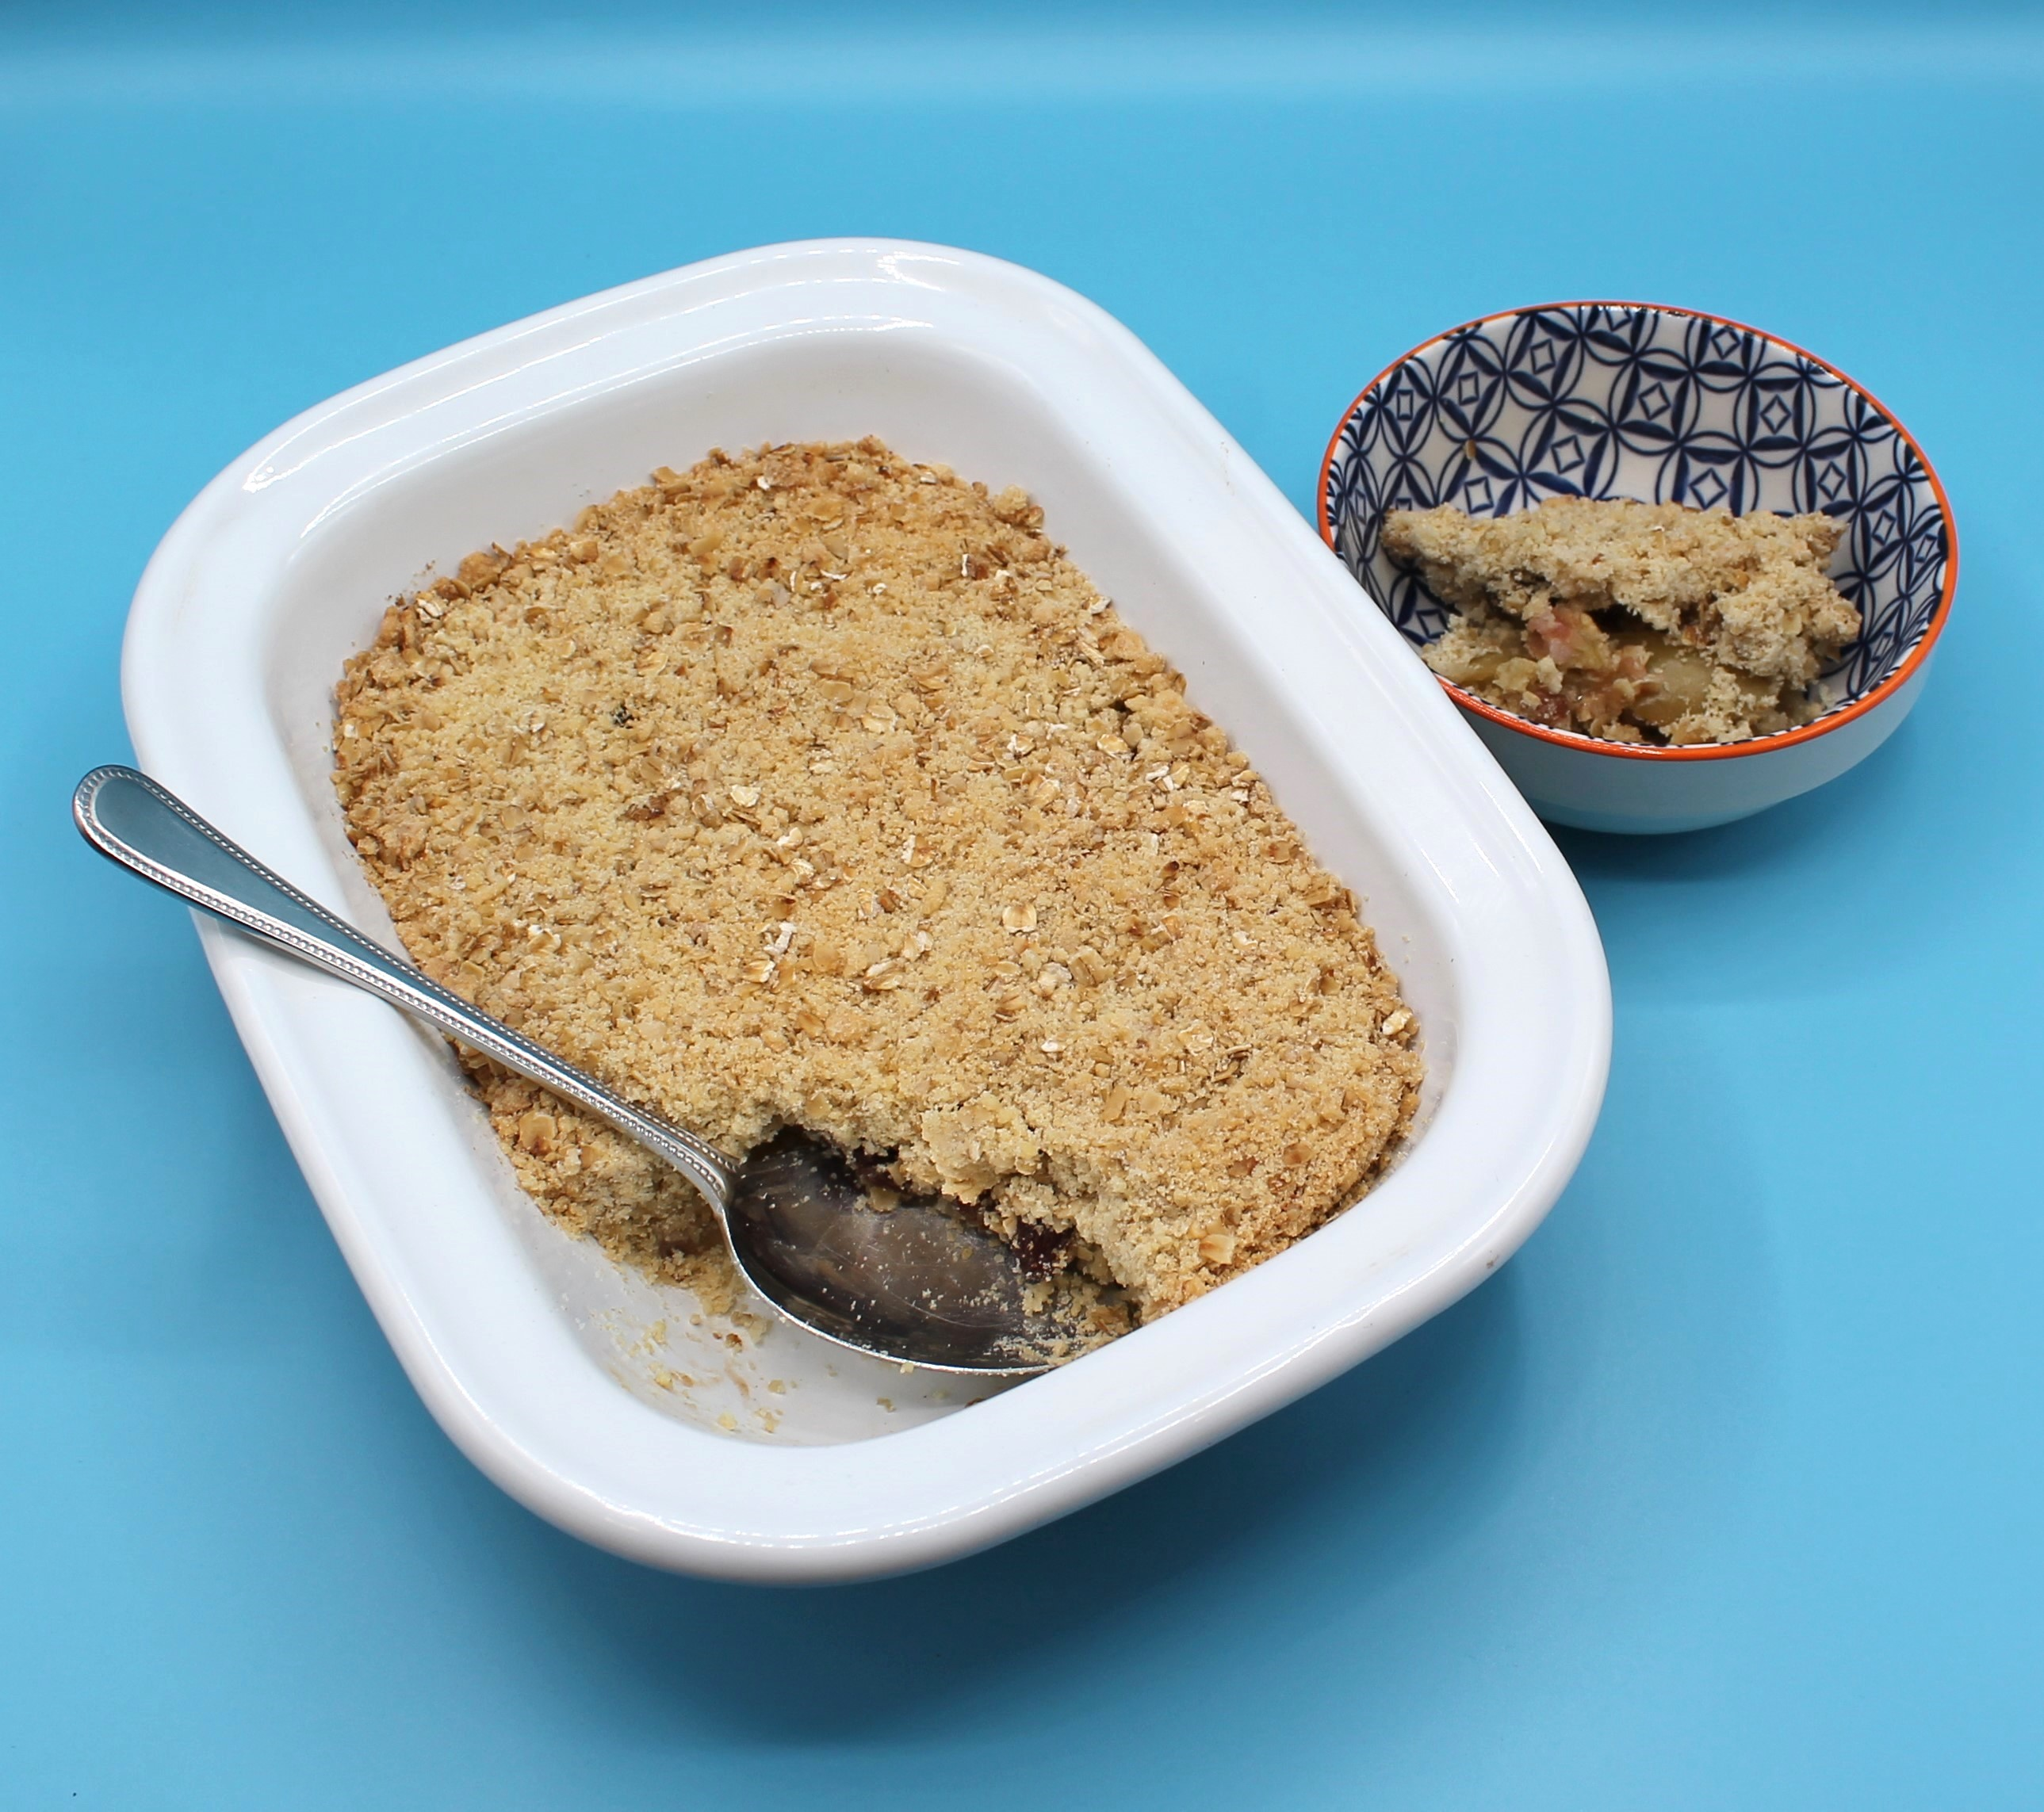
Complexity: low - medium
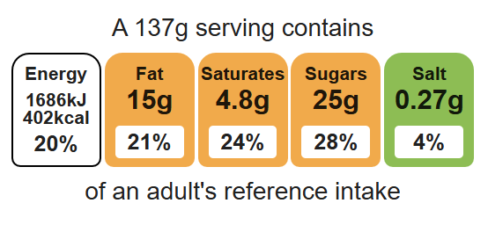

Ingredients (serves 3)

Equipment

Weighing scales

Mixing bowl

Mixing spoon

Chopping board

Sharp knife

Ovenproof dish (21cm) or foil tray

Baking tray

50g baking fat/block
50g plain white flour
50g plain wholemeal flour
50g oats
25g sugar
2 cooking apples
50g sultanas

Method
- Preheat oven to 190°C or gas mark 5.
- Rub the fat into the flour using your fingertips, until it resembles breadcrumbs.
- Stir in the oats and sugar.
- Cut the apples into quarters and remove the core on a clean chopping board. Slice thinly.
- Arrange the apple slices in an oven proof/foil tray dish and then add the sultanas.
- Sprinkle the crumble topping over the apple slices.
- Place the crumble on a flat baking tray to avoid any spillages in the oven.
- Bake for 25 – 30 minutes, until the apples are soft, and the crumble is golden.

Top tips
- Reduce food waste: Use up any leftover fruit such as, apricots, berries, peaches, plums or pears. The fruit can be canned, dried or frozen.
- Focus on fibre: Use wholemeal flour for the crumble topping.
- Turn up the flavour: Try adding ½ x 5ml spoon cinnamon to the fruit to enhance the flavour.

Food skills
Weigh, rub- in, core, cut, chop, slice, dice and trim, mix, stir and combine, layer, bake.

