The digestive system
Do you know the body parts involved in the digestion process?
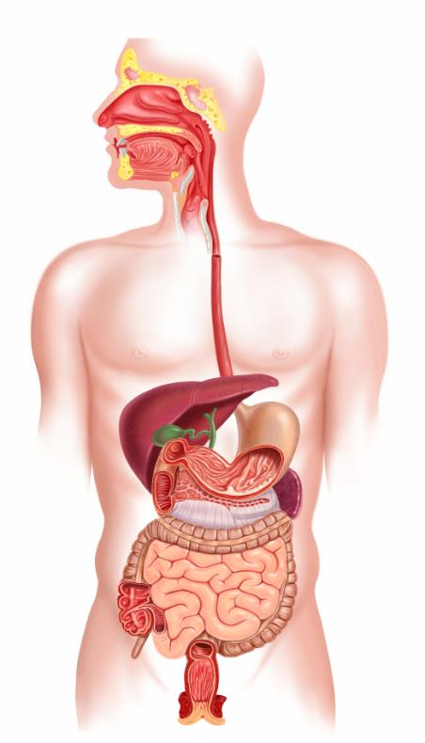
Draw an arrow to different parts of the digestive system and label them.

