Classic tomato ragu
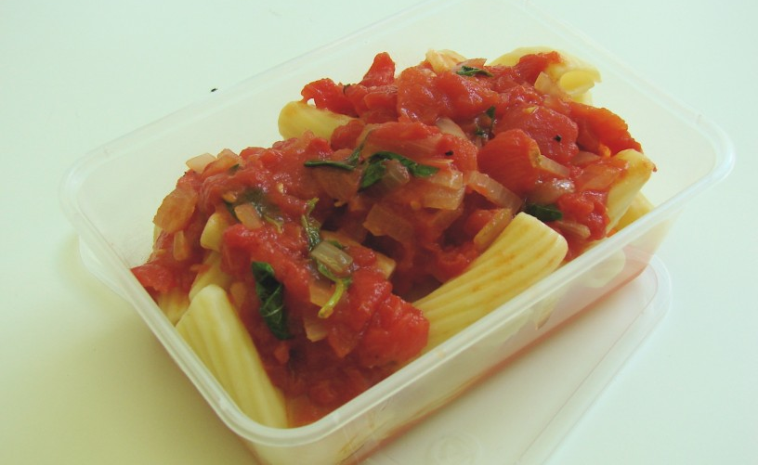
Complexity: low - medium
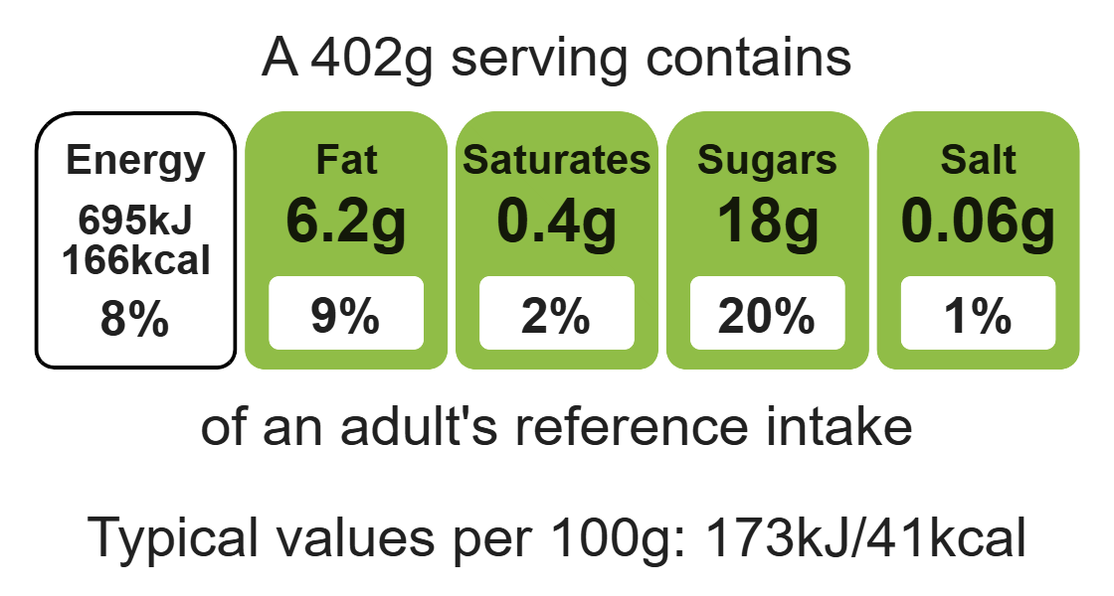

Ingredients (serves 2)
1 onion
1 clove garlic
1x15ml spoon oil
1 x 400g canned chopped tomatoes

Equipment

sharp knife

chopping board

garlic press

measuring spoons

saucepan

heat-resistant spoon

handful of fresh basil
black pepper

Method
- Peel and chop the onion.
- Peel and crush the garlic.
- Fry the onion and garlic in the oil for 5 minutes, until soft.
- Add the tomatoes and tear in the basil leaves.
- Add a few twists of black pepper, then allow to simmer gently for 30 minutes (longer if possible).

Optional
You may wish to serve the tomato ragu with pasta if so:
- after 15 minutes, put a large saucepan of water on to boil. When rapidly boiling, add the pasta and cook for around 10 minutes until al dente;
- drain;
- mix the cooked pasta and tomato sauce together.

Top tips
- Reduce food waste: Use up any leftover vegetables such as 75g of mushrooms, courgette, or pepper.
- Vary your protein: Add 200g of minced beef, chicken or beans to step 2.
- Focus on fibre: Serve with wholemeal pasta to boost the fibre content.
- Turn up the flavour: Try adding 1 x5ml spoon dried chilli flakes, oregano, smoked paprika to the sauce.
- Serving suggestion: Pour the sauce over white fish, sprinkle with cheese and bake for 20 minutes.

Food skills
Measure, peel, cut, chop, slice, dice and trim, fry and sauté, melt, simmer and boil.

