Quick bean enchiladas

Ingredients
Complexity: medium-high

1 red onion

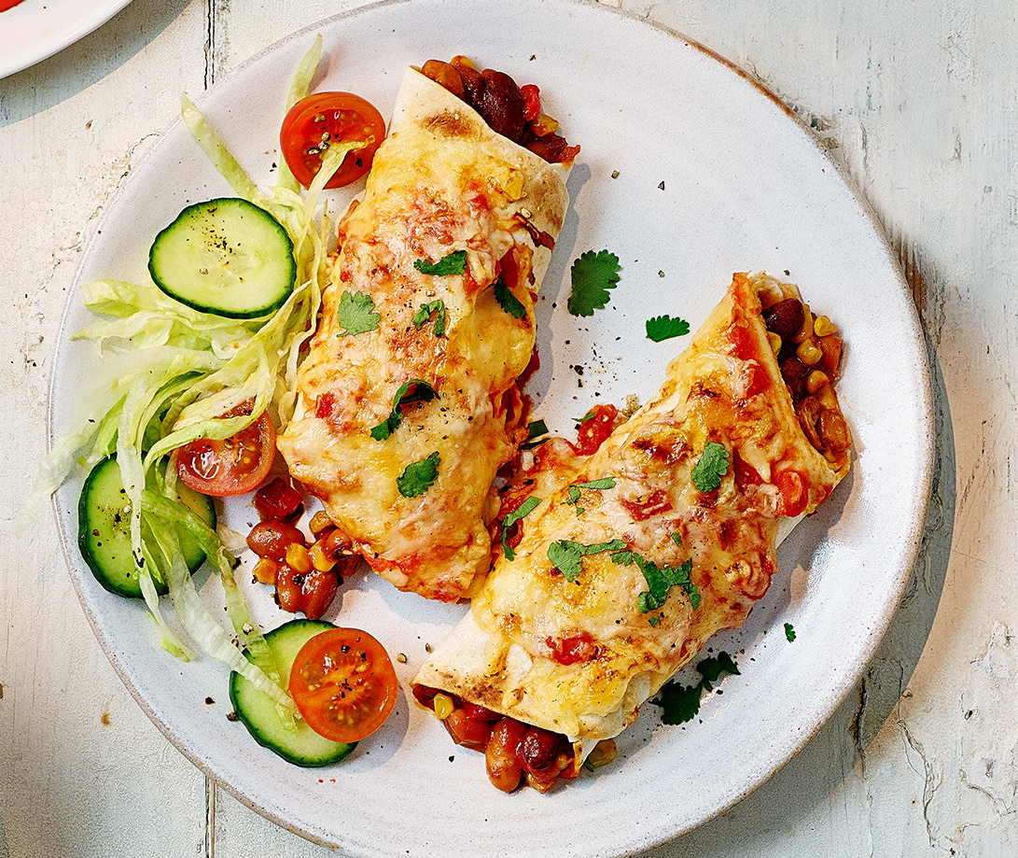
½ red pepper

2 garlic cloves

160g canned sweetcorn

395g can beans in taco or chilli sauce

Spray oil

2 wholemeal tortilla wraps

200g tin chopped tomatoes

25g reduced-fat cheddar cheese

To serve - optional

6 cherry tomatoes

15g coriander

¼ cucumber

¼ iceberg lettuce

Equipment

Chopping board, vegetable knife, garlic press, sieve/colander, grater, frying pan, mixing spoons, can opener, ovenproof dish.

Method
- Prepare the ingredients:
- peel and finely chop the onion;
- deseed and finely chop the pepper;
- peel and crush the garlic;
- drain the sweetcorn;
- grate the cheese.
- Lightly spray a frying pan with oil and place over a medium heat. Add the onion, pepper and garlic and cook for 5 minutes until the vegetables are beginning to soften.
- Add the sweetcorn and beans, bring to the boil and simmer for 5 minutes, stirring occasionally.
- Pre-heat the grill on high.
- Spoon the beans evenly down the centre of the 2 tortilla wraps and roll up to seal.
- Place in a small ovenproof dish and top with the chopped tomatoes and cheese.
- Grill for 5 minutes until golden and bubbling.
- Prepare the accompaniments:
  - halve the cherry tomatoes;
  - roughly chop the coriander;
  - roughly chop the cucumber;
  - finely shred the lettuce.
- Scatter with the chopped coriander and serve with the tomatoes, cucumber and lettuce.
Top tips
- Add 2 x 5ml spoons chili powder for an extra kick of flavour.
- Try seeded or flavoured wraps.
- Serve the bean filling with cooked brown rice, couscous or quinoa.

Food skills
- Weigh
- Peel
- Cut
- Chop
- Crush
- Drain
- Grate
- Sauté
- Boil
- Simmer
- Mix
- Grill

Did you know?
Enchiladas (which means ‘season with chili’) originated in Mexico, where the practice of rolling tortillas around other food dates back at least to Aztec times. Today, an enchilada is a popular street food in Mexico and in many countries in South America.

This recipe was adapted from a recipe for Quick bean enchiladas, which was kindly donated by Tesco plc.

