Healthy Eating Week Tutor Time Activities
Food and drink choice
Activity one
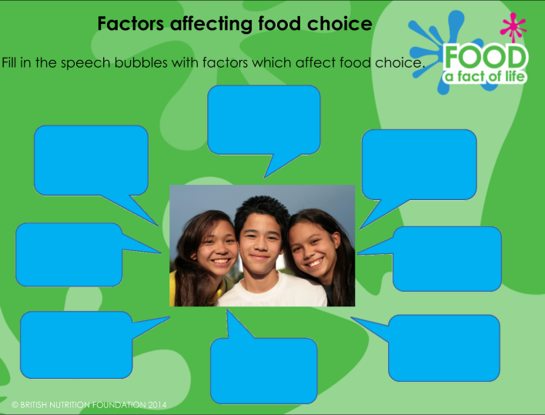
Using the Food choice PowerPoint, ask pupils to name as many factors affecting food choice as possible. Ask pupils whether the factors affecting their food choice would change in different scenarios and why they think that would be (e.g. eating out at a restaurant with friends, attending a party for a special occasion with family, choosing to prepare and cook a meal for one person only).

Activity two
You could discuss the Food and drink choice discussion topics with your tutor group. A discussion PowerPoint slide and some stimulus questions are provided.

