Healthy Eating Week Tutor Time Activities
Food preparation and cooking – let’s all get cooking!

Activity one
Carry out the Ready steady cook cards activity. Print and cut out multiple copies of the Ready steady cook cards and place in a way pupils will not be able to see the cards (e.g. in a hat, face down on a desk). Divide the class evenly into small groups of three or four. Each group must select 5 cards and will have 2 minutes to create a meal idea using those food cards. Each group can then present their meal idea to the rest of the class. A class vote could be held to decide the best meal idea.
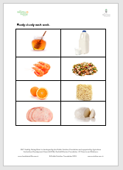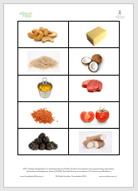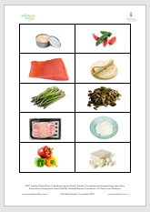

Activity two
Why not discuss the Food preparation and cooking questions with your tutor group?
- Survey the class – how many people never cook at home? How many people sometimes cook at home? How many people cook at home once a week? How many people cook at home every day? What are your reasons for cooking or not cooking at home?
- Where do you get recipe ideas from?
- What are the benefits from learning how to cook?
- What are your speciality dishes?
- How many people would like to cook more? Why would you like to cook more?
- Who taught you how to cook?
- How many people watch a cookery TV show at least once a week? Have you ever tried to recreate a recipe from a TV show?
- What skills would you like to learn about food preparation and cooking?

