Crunchy chickpea sandwich
Ingredients
Complexity: medium
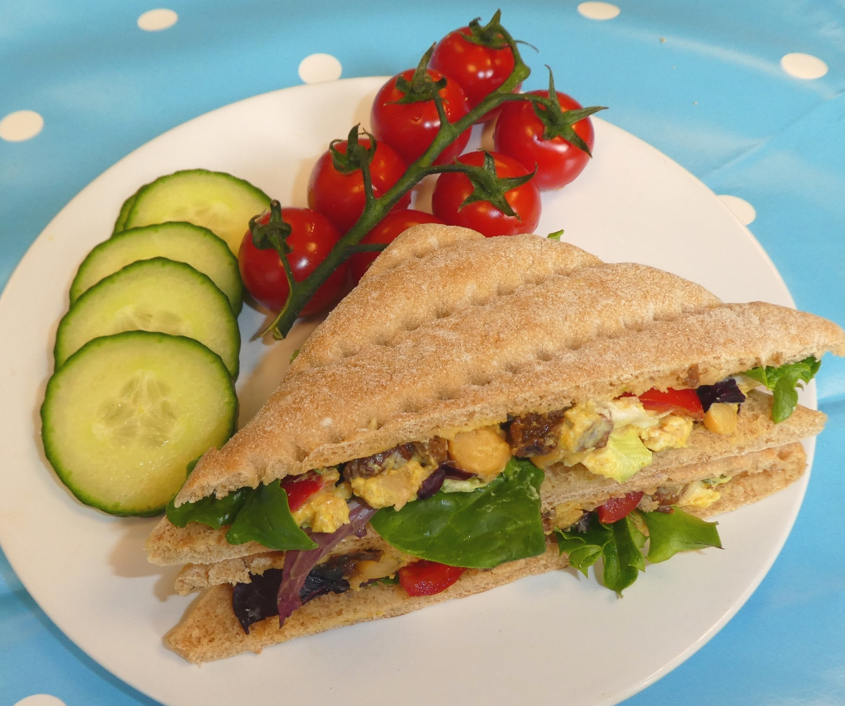
4 x wholemeal rolls or thins, halved
1 x stick celery, trimmed
½ x red pepper, deseeded
1 x spring onion, trimmed
50g sultanas
100g canned chickpeas, drained
4 x 15ml spoons reduced fat soft cheese
1 x 5ml spoon mild curry powder
Handful lettuce leaves, washed

Equipment
Small mixing bowl, fork, chopping board, vegetable knife, kitchen scissors, 2 mixing spoons, table knife, 1 large plate.

Method
- Place the chickpeas in the bowl and crush with the fork.
- Slice the celery.
- Snip the pepper into small pieces.
- Snip the spring onion into small pieces.
- Mix all the ingredients (except the lettuce and bread) together, thoroughly.
- Open a roll or thin and spoon a quarter of the mixture onto one half.
- Place a few lettuce leaves on top of the mixture.
- Close the sandwich and put it on the plate.
- Repeat with the other 3 rolls or thins.
- Serve.

Top tips
- Try other ingredients in the sandwich filling such as sweetcorn, grated carrot, chopped apple or pineapple.
- Try different types of bread.
Teacher tips

You will need weighing scales and measuring spoons to prepare the recipe ingredients.

Using bread rolls? You will need a bread knife and chopping board to halve these.

The equipment list includes a vegetable knife for slicing the celery. A sharp/serrated table knife may also work as an alternative, but do test it in advance. It needs to cut the celery easily.

- Serve with a salad garnish.

Food skills
- Cut and slice.
- Snip.
- Mix.
- Arrange.

