Mexican pockets
Complexity: medium-high

Ingredients

1 spring onion

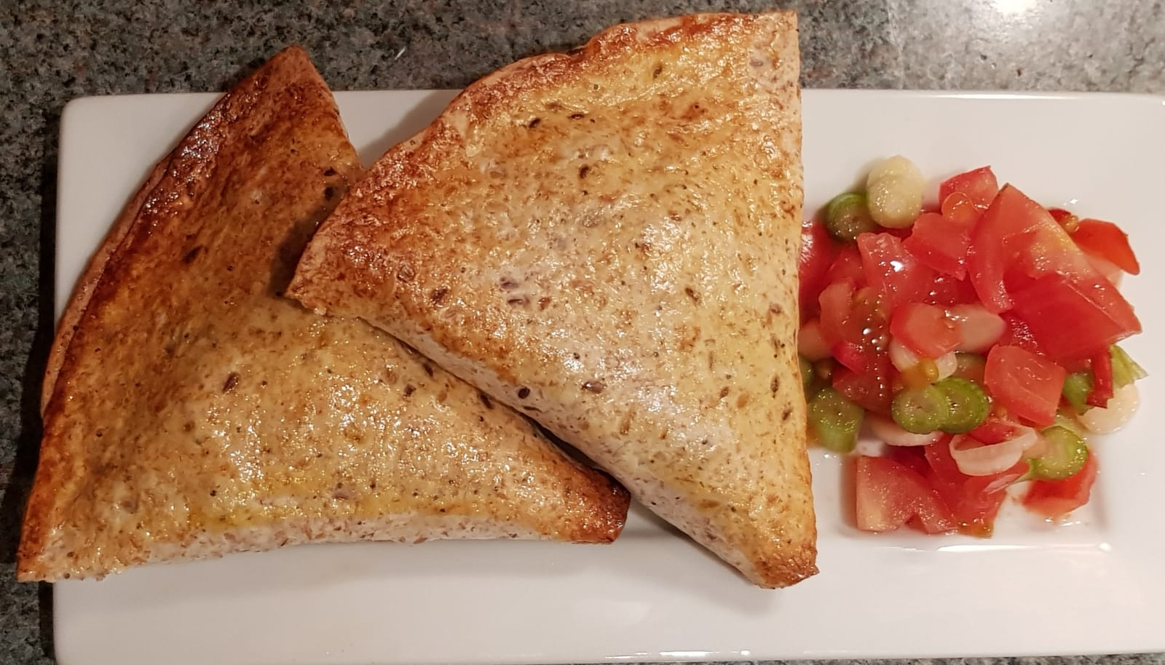
½ red, yellow or green pepper

25g cooked chicken or tofu

20g reduced fat Cheddar cheese

50g canned kidney beans, drained and rinsed

25g frozen peas

25g canned or frozen sweetcorn

½ x 5ml spoon chipotle paste or 1 x 5ml spoon mild chilli powder

1 egg

2 large tortilla wraps or 4 mini wraps

Quick salsa

1 tomato

1 spring onion

1 x 5ml spoon lime juice

¼ fresh chilli

Equipment
Measuring scales, baking tray, colander, mixing bowl x 2, small vegetable knife, chopping board, mixing spoon, measuring spoons, jug, fork, pastry brush, juicer.

Method
- Heat the oven to 200°C/gas mark 6. Line or lightly grease a baking tray.
- Prepare the filling ingredients and place in a bowl:
  - Slice or snip the spring onions into rings;
  - Dice the pepper;
  - Chop the cooked chicken or tofu;
  - Grate the Cheddar cheese.
- Add the kidney beans, peas and sweetcorn to the bowl.
- Stir in the chipotle paste or chilli powder.
- Crack the egg into a jug and mix well with a fork.
- Cut the wraps in half and brush the edges of each half with the beaten egg.
- Leave for 30 seconds and then fold into a cone shape sealing the edges carefully.
- Fill each cone 2/3rds full with mixture. Do not overfill otherwise they will be difficult to seal.
- Brush the inside edges with egg. Leave for 30 seconds and then seal by pressing the edges together firmly.
- Place the pockets on the baking tray and brush with egg.
- Bake in the oven for 10 minutes until golden.

While the pockets are baking, prepare the salsa ingredients:

- dice the tomato;
- slice or snip the spring onion;
- finely dice the fresh chilli;
- squeeze the lime;
- place all the ingredients in a small mixing bowl, add 1 x 5ml spoon lime juice and mix well.

Top tips
- Try different wraps such as wholemeal, tomato and herb or seeded.
- For a non-wheat version of this recipe, use corn tortillas or gluten free wraps.
- For a filling with a bit more of a kick, add ¼ finely diced fresh chilli or another ½ x 5ml spoon of chipotle paste. If you do not like spicy food, you can remove the chilli altogether.

Food skills
- Weigh.
- Chop, slice and dice.
- Grate.
- Mix, stir and combine.
- Shape.
- Glaze.
- Bake.
- Juice.

