Cooking on a budget: Healthy, affordable dishes

Food shopping is a major household cost, and inflation is adding pressure to already stretched budgets. There are ways in which costs can be reduced, the following tips and ideas explain how.

Smart shopping
Plan meals for the week and make list and stick to it! Be economical with ingredients, for example if half a can of tomatoes is needed for one recipe, plan another recipe to use up the other half. When shopping, try not to deviate from the list and never go shopping when you are hungry.
When planning meals for the week, think about what food is in season. Produce that is in season should have travelled fewer food miles and it will generally be cheaper. Print out a list of what is in season and when, to help.
Avoid pre-sliced or chopped ingredients – they are not good value for money. The packaging usually means you will get much less than if you bought it whole and they often cost more. Did you know…hard to chop ingredients like butternut squash can be softened slightly by giving them 1 minute in the microwave?
Supermarkets have several different ranges of own-label products, from basic and value brands to premium. Often ‘own brands’ are very similar to branded items and are much cheaper.
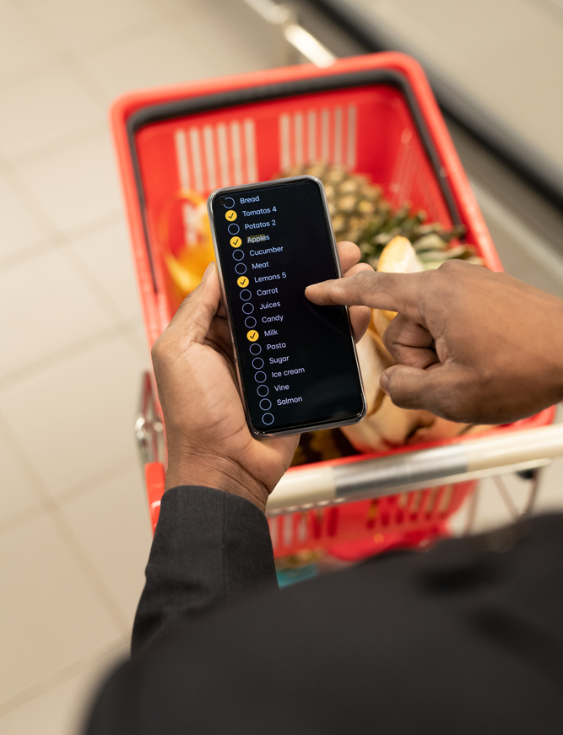

Market traders often have lower overheads and pay less for their fresh produce, meaning they can sell them on at a much cheaper price. Freeze any surplus ingredients for future use.

Grocery prices can vary from week to week so stocking up on store cupboard items (bought regularly) when discounted, saves money.

Look out for ‘wonky fruit and veg’! Many supermarkets would have previously thrown out their imperfectly shaped fruit and vegetables but now sell them on to customers more cheaply, helping to reduce waste.

Know the difference between use-by and best-before dates!
Use-by – you have got until the end of this date to use or freeze the food before it becomes too risky to eat. Best-before – you can eat food past this date, but it might not be at its best quality.

Confident cooking

Try batch cooking – it is much cheaper to buy extra ingredients for the same dish than to buy new ingredients for separate recipes. You will also save on total energy used too.
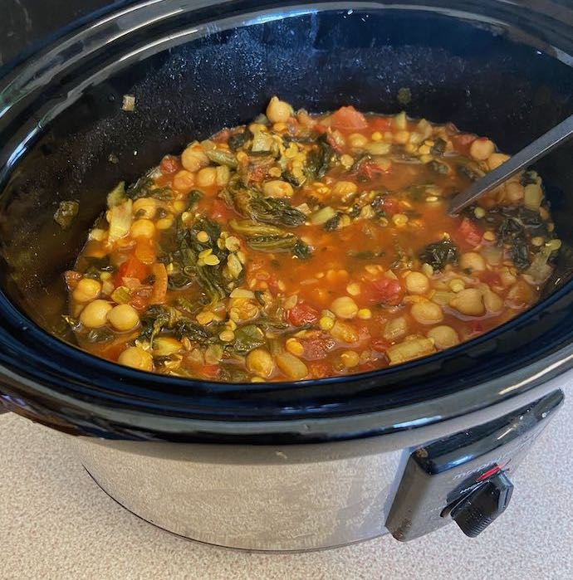
Using a pressure cooker or air fryer cuts down on cooking time. Using a pressure cooker or slow cooker allows you to buy cheaper ingredients that usually need a longer time to cook. These include beans and pulses and cheaper cuts of meat.

When bringing water to the boil on the hob, cover the pan as it significantly reduces the heating-up time and therefore saves 85% of the energy an uncovered pan would use. Did you know, it costs less to boil water in a kettle than on the hob?

Did you know microwaves are cheaper to use because they only heat the food inside them unlike ovens that also heat the air around the food – plus, food takes much less time to cook?

Keep the door shut! Each time you open the oven door, the oven loses heat – sometimes as much as 25 degrees. Make sure you know how long it takes your oven to heat up, so you are ready to start cooking when it’s ready.
Matching the pan to the size of the hob is the most efficient way of cooking. If the hob is too big you will lose energy on the sides, while a small hob will not effectively heat the whole pan.

Make your favourite takeaway food at home, for example curry and rice or stir fry with noodles. It will cost less and taste just as good!

Nutritious and delicious
Couscous, bulgur wheat, rice, quinoa, or pasta can help bulk up salads and leftover vegetables, or make a bowl of soup into a completely different dish. Cheap to buy and easy to store, these ingredients are high fibre foods, helping to keep you feeling fuller for longer.
When browning vegetables, put them in a hot pan then spray with oil, rather than adding the oil first to the pan. This reduces the amount of oil that vegetables absorb during cooking.

Check portion size – It is easy to eat more than you need, and food often comes in larger portion sizes than you need.
You may be able to get more from a meal if you measure out the recommended sizes. For example, a serving portion of chicken should fit in the palm of your hand, and 75g of dried pasta, is enough per adult.
Adding pulses to meat dishes means you can use less meat, which saves money. Pulses also add nutrients and fibre to the dish. You can add chickpeas to a chicken curry or lentils to a meat-based pasta sauce, or tofu to a stir fry.

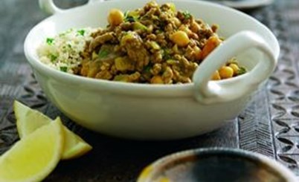

Canned fish, beans and lentils (canned or dried) and eggs are all relatively low-cost proteins and can be stored. If you can buy in bulk this may be even cheaper.
Frozen fish and meat can also be cheaper options.

Frozen fruit and vegetables can be good value and nutritious as the nutrients are ‘sealed in’ during the freezing process. They are also pre-prepared which makes cooking quicker and easier. Try adding some to your meals, for example, add berries to your porridge or peas to your rice.

Grow your own ingredients! Visit a local allotment, school, or community garden as they may have cheap fruits and vegetables for sale.

Cut the waste
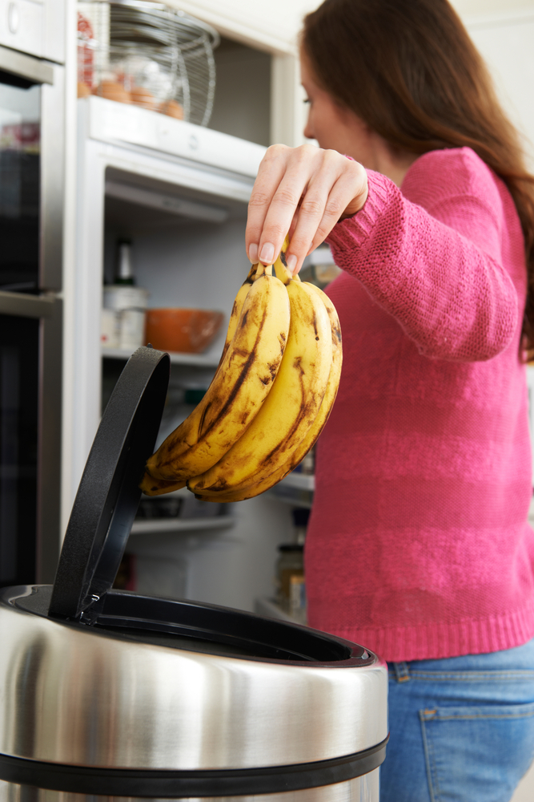
Perishable items, such as fruit and vegetables, each have their best way to store to avoid spoilage. Some tips include:
- keeping the refrigerator below 5°C;
- storing cooked foods on shelves above raw foods;
- storing food in sealed containers.
Always transfer leftovers from open cans into a suitable container. Do not store it in the can.

Move older products to the front of your cupboard or fridge and new ones to the back. Use airtight containers to keep open food fresh in the fridge and ensure packets are closed to stop insects from getting in.
Lots of leftovers can be made into sauces or dips. Leftover beans or pulses can be mashed or blended with some garlic, lemon juice and herbs for a hummus-style dip. Slightly over-ripe avocados are good for guacamole, and tomatoes, peppers and cucumbers which need using can go into home-made salsa.
Get creative with leftovers - soups, curries, risottos and stir fries can all have a few extra ingredients added.
Aim for perfect portions - you can use scales or measuring spoons to follow recipes. If you cook too much, freeze the leftovers or eat them for lunch the next day.
Did you know…leftover juice, milk, yogurt and fruit can be turned into delicious ice lollies. All you need to do is blend the ingredients together and pour into some moulds with a lolly stick.
Did you know… “FIFO” stands for “first in, first out” and is a useful way to organise food at home
Leave fruit and vegetable skins on wherever possible and suitable. If peeling is required, some peelings can be added to recipes like soups or stews. Why not try potato peelings crips?

Use up stale bread. Blitz it in a blender to make some breadcrumbs and put them in the freezer. Breadcrumbs can be used to top pasta bakes, coat pieces of meat or fish. If you don't have a blender, you can break down the bread with your hands - it just takes a little longer.
This resource meets the Guidelines for producers and users of school education resources about food.

