Label the digestive system
Do you know the body parts involved in the digestion process?
Link the body part name to the correct part of the body.
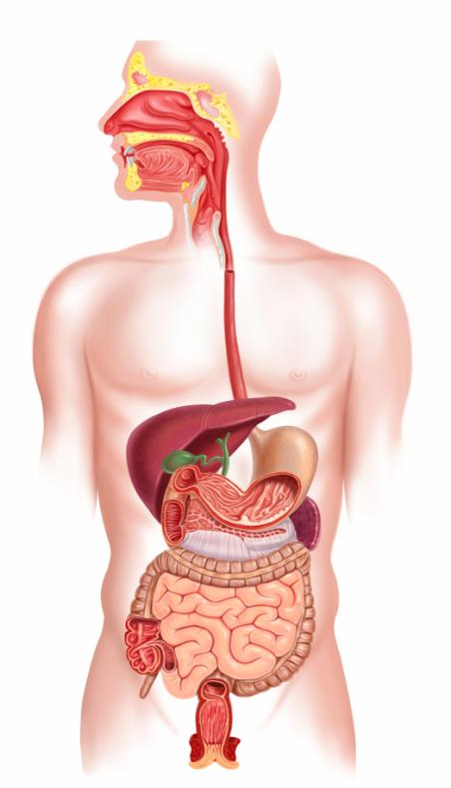
Large intestine
Mouth
Oesophagus (gullet)
Small intestine
Stomach

