Beef lasagne


Complexity: medium- high
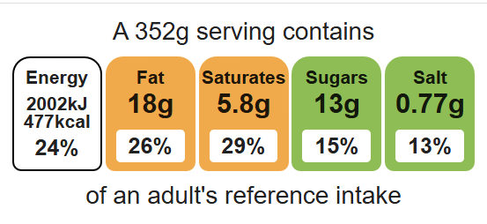

Ingredients (serves 3)

1 onion

Equipment

Chopping board

Sharp knife

Garlic press

Vegetable peeler

Large frying pan

Heat resistant spoon

Measuring spoons

Measuring jug

Small saucepan

Grater

Ovenproof dish

1 clove garlic

1 carrot

1 x 15ml oil or spray oil

250g lean minced beef

400g canned chopped tomatoes

1 x 15ml spoon tomato puree

1 x 5ml spoon mixed herbs

Black pepper

25g reduced-fat spread

25g plain flour

300ml semi-skimmed milk
50g reduced-fat cheddar cheese

6 lasagna sheets
100ml water
Top tips
- Reduce food waste: Add any leftover vegetables to your lasagne.
- Turn up the flavour: Try using lasagne sheets flavoured with spinach
- For a meat-free alternative: Add lentils or mixed beans instead of the minced beef.

Method
- Preheat the oven to 190°C or gas mark 5.
- Prepare the vegetables:
- peel and dice the onion;
- peel and crush the garlic;
- peel and dice the carrot.
- Fry the onion, garlic and carrot in the oil.
- Add the meat and cook until the mince is lightly browned.
- Add the tomatoes, tomato puree, mixed herbs, black pepper and water and mix all the ingredients together.
- Bring to the boil, then simmer for 20 minutes.
- While the meat sauce is cooking, make the white sauce:
- place the reduced-fat spread, flour and milk in a saucepan;
- bring the sauce to a simmer, stirring continuously until it has thickened;
- reduce the heat and simmer for 2 minutes;
- grate the cheese and stir in half to the sauce off the heat.
- In an ovenproof dish or foil tray, spread some meat mixture in the bottom, cover with lasagne sheets and a little cheese sauce. Repeat this, finishing with the sauce on top.
- Sprinkle the remaining grated cheese and bake for 20 minutes.

Food skills
Weigh, measure, peel, cut, chop, slice, dice and trim, crush, fry and sauté, melt, simmer and boil, mix, stir and combine, grate, layer, bake.

Method

