Analysing bread flour
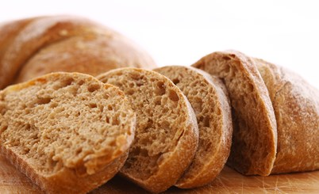
Introduction

Calculate the fibre content of three different loaves of bread: one made with white flour; one with 50% white and 50% wholemeal flour; and, one with only wholemeal flour.

Task 1:
- Go to Explore Food http://explorefood.foodafactoflife.org.uk/
Bread recipe

Ingredients
250g strong white flour
1/2 x 5ml spoon salt
7g pack fast action dried yeast
150ml warm water
- Click on ‘calculate a recipe’. The bread recipe on the right contains 250g of strong white bread flour. Search for this flour and add it to your recipe.

- Record how much fibre this flour provides.

- Repeat the above, but for a mixture of 125g strong white and 125g strong wholemeal flour. Repeat again, using 250g of strong wholemeal flour.

- Compare the amount of fibre in these flours to the white flour.

Questions:
__________ grams
__________ grams

__________ grams

__________ grams

How much fibre does the 250g strong white flour contain?
How much fibre does 125g strong white + 125g strong wholemeal flour contain?
How much fibre does the 250g strong wholemeal flour contain?

How much more fibre does a wholemeal loaf provide than a white loaf?

Task 2:
Use the recipe above to make bread, using white flour (see full instructions on next page). Then, adapt the recipe to use wholemeal flour and either brown flour or a 50/50 mix of wholemeal and white flours, for a total of three different breads.

When making the dough, the more wholemeal flour it contains, the more water you will need to make a soft dough.

Compare the three different loaves and complete the Bread analysis table worksheet with your findings.

Bread – three ways

Activity

Make three different types of bread and compare.

Ingredients

Loaf 1 | Loaf 2 | Loaf 3
250g strong white flour  1/2 x 5ml spoon salt  7g pack fast action dried yeast  150ml warm water | 125g strong white flour  125g strong wholemeal flour  1/2 x 5ml spoon salt  7g pack fast action dried yeast  150ml warm water | 250g strong wholemeal flour  1/2 x 5ml spoon salt  7g pack fast action dried yeast  150ml warm water

Equipment

3 baking trays, grease proof paper, sieve, mixing bowl, weighing scales, measuring jug, measuring spoons, flour dredger, oven gloves and cooling rack.

Method – For each loaf, follow these instructions

- Preheat the oven to 220ºC or gas mark 7.
- Line the baking tray with greaseproof paper.
- Sieve together the flour and salt into the mixing bowl.
- Stir in the yeast.
- Make a well in the middle of the flour mixture and add the warm water. Mix to form a soft dough. (Note: you may need additional water for loaves 2 and 3. If so, record the amount used)
- Sprinkle a little flour onto a clean work surface and place the dough on the surface.
- Knead the dough for 10 minutes.
- Shape into a loaf.
- Place the loaf on the greased baking tray.
- Cover the dough and leave to prove for 30 minutes in a warm place, until it doubles in size.
- Bake for 15 - 20 minutes until golden brown.

