Understanding allergens

Whether you are making food for yourself, family or friends it is important to be aware that some ingredients may cause an allergic reaction in some people. There are fourteen major allergens that must be identified on a food label:

Cereals containing gluten
Crustaceans, for example, prawns, crab, lobster and crayfish
Eggs
Fish
Peanuts
Soybeans
Sulphur dioxide, which is a preservative found in some dried fruit
Lupin (found in some flour-based or gluten free products)
Molluscs, for example, clams, mussels, oysters, whelks, snails and squid
Milk
Nuts such as almonds, walnuts, hazelnuts, pecans, Brazil nuts, pistachio, cashew, macadamia (Queensland)
Celery (and celeriac)
Mustard
Sesame

Task 1
Using the information above, identify the allergens in the three recipes below.
Task 2
Produce an ingredients list that could be included on a food label. Remember that ingredients should appear in descending order of weight and allergens could be identified in bold, highlighted, underlined or in italics.
Lamb Apricot and Coriander Burgers
450g (1lb) lamb mince
25g (1oz) dried apricots
25g (1oz) shelled pistachio nuts or almonds (optional)
1 x 15ml spoon (1tbs) coriander
1 lemon
Freshly ground black pepper

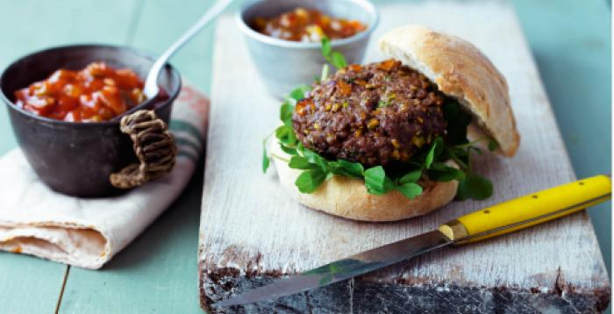

Recipes can be found on
https://www.foodafactoflife.org.uk/recipes/
Ramen Burgers with Tonkatsu Sauce
450g (1lb) beef mince
2x 100g packs instant ramen noodles, flavour sachets discarded
2 eggs
Freshly ground black pepper
1x 15ml spoon (2tbs) sunflower oil
1x 5ml spoon (1tsp) dry mustard powder
200ml (7fl oz) tomato ketchup
4x 15ml spoon (4tbs) Worcestershire sauce
4x 5ml spoon (4tsp) light soy sauce
1.25cm (½ inch) fresh root ginger
1 small red onion
Blazing Burgers
450g (1lb) lean beef mince
1 small red onion
1.25cm (½ inch) fresh root ginger
1 green chilli
1x 5ml spoon (1tsp) Worcestershire sauce
½x 5ml spoon (½tsp) salt
1x 15ml spoon (1tbs) oil

