Quick Jamaican coco bread

Ingredients
Complexity: medium
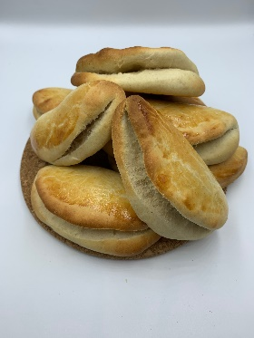
Spray oil
120ml light coconut milk
1 x 15ml spoon sugar
½ x 5ml spoon salt
25g butter or reduced fat spread
1 small egg
1 sachet fast action yeast
250g plain flour

Equipment
Baking tray, greaseproof paper, medium mixing bowl/small saucepan, large mixing bowl, small bowl, fork, mixing spoon, knife or palette knife, rolling pin, pastry brush, cooling rack.

Method
- Line a large baking tray with greaseproof paper, spray with spray oil.
- In a medium bowl, combine coconut milk, sugar, salt and butter/reduced fat spread. Heat in a microwave for about 30 seconds or more, until the fat melts. Do not let it boil or overheat. If the liquid becomes too hot, it will kill the yeast. Alternatively, heat gently in a small saucepan.
- Pour the warm liquid into large mixing bowl.
- Crack the egg into a small bowl and beat with a fork. Add most of the beaten egg to the mixing bowl. Retain a small amount of the egg to glaze the bread with before baking.
- Mix the yeast into the liquid.
- Stir in three quarters of the flour at first, to form a soft dough. Add more flour if need be. Do not add too much flour as a soft dough results in tender coco bread.
- Turn dough onto a lightly floured surface and knead gently for 3-4 minutes.
- Divide the dough into eight equal pieces.
- Roll each piece with a rolling pin to about 10-12cm diameter and about ½-1cm thick.
- Fold a dough circle in half and place on the prepared baking tray, repeat with remaining pieces. Brush the tops with the remaining beaten egg.
- Place the baking tray into a COLD oven and turn up the temperature immediately to the highest setting.
- Remove from oven after approximately 15 minutes and cool on a cooling rack.

Top tips
- To get an even thickness for your coco bread, place each circle between two wooden spoons and roll out.
- If time allows, leave the dough to rest for an hour before shaping and then again for 10-15 minutes before baking. Serve the bread warm or allow to cool.
- Jamaican coco bread is easy to make ahead of time. It can be stored in an airtight container in the freezer for up to 2 months. De-frost and re-heat in the oven.
- This recipe is a great way to use up any leftover coconut milk. However, coconut milk can be frozen in ice cube trays to use when you need it. Defrost and stir well before using.

Food skills
- Weigh
- Measure
- Melt
- Mix
- Stir
- Knead
- Divide
- Roll-out
- Shape
- Bake

Did you know?
Jamaican coco bread is a buttery, subtly sweet folded bread. It gets part of its name from the coconut milk used to give a tropical flavour. Like many traditional Jamaican foods, coco bread was made when there was a need to make simple yet tasty food. This recipe is presumed to have been created by an enslaved person with few ingredients available.

Coco bread goes with a wide variety of dishes. Beef patty is popular - coco bread stuffed with seasoned beef - or they can be eaten with jerked chicken or fish. They can also be served with soups and stews.

