Fats and their functional properties
in food products

- Identify the fatty acids below as either saturated, monounsaturated or polyunsaturated. Label each of them with the correct term.

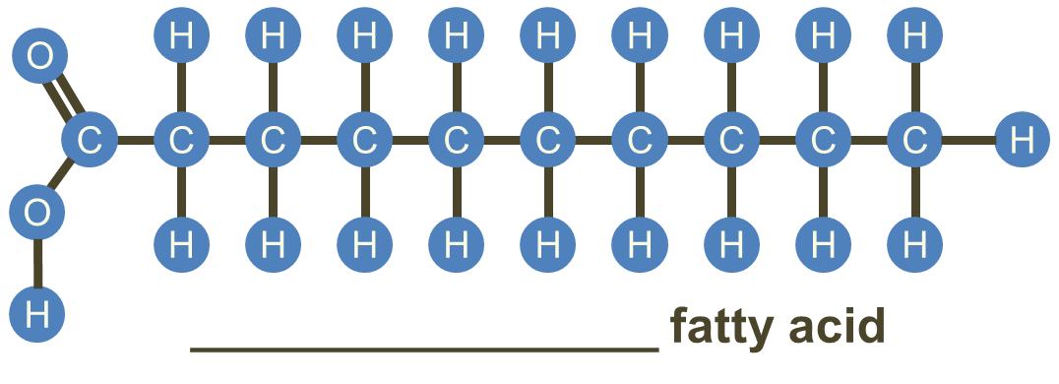
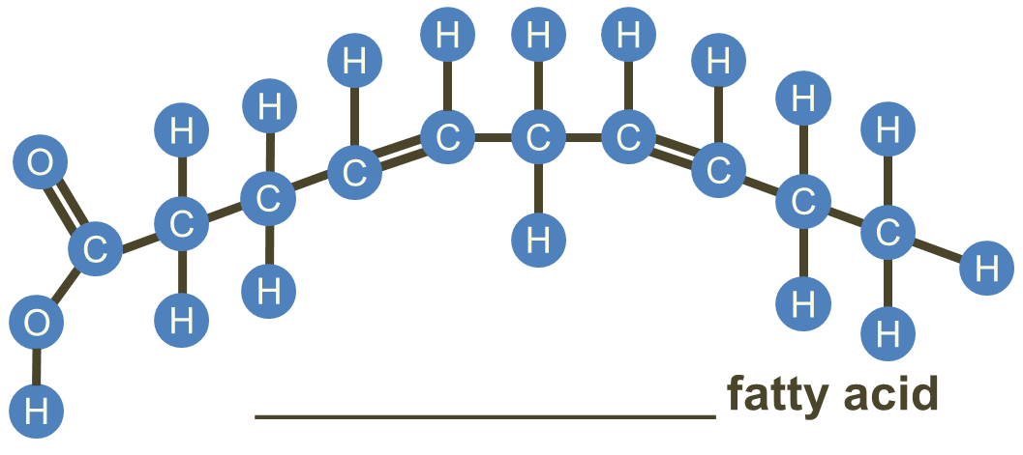

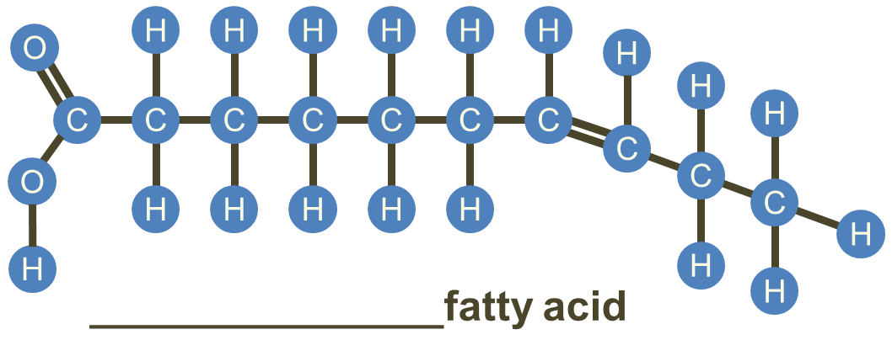

- Explain why butter is considered to be a saturated fat, even though it contains some unsaturated fatty acids.
______________________________________________________________________

______________________________________________________________________

______________________________________________________________________

- Describe two different ways in which manufacturers can solidify vegetable oils.
______________________________________________________________________

______________________________________________________________________

______________________________________________________________________

- Explain why partially hydrogenated vegetable oils may pose health risks.

______________________________________________________________________

______________________________________________________________________

- Explain what happens to a fat when it becomes oxidised.
______________________________________________________________________

______________________________________________________________________

______________________________________________________________________

- Name the functional property that matches each description:
- Fats do not melt at fixed temperatures but over a range. This is due to the mixture of triglycerides, each with their own melting point.
____________________________________
- The fat coats the flour particles and prevents them from absorbing water, reducing the gluten development.
____________________________________

- Explain how using shortening can change the properties of a food product. Give an example of a food that uses shortening.

______________________________________________________________________

______________________________________________________________________

______________________________________________________________________
______________________________________________________________________

- Complete the table below, describing the functional properties of fats. Give at least one example of a food that uses each property.

Functional property | Description | Examples in food
Shortening

Plasticity
Aeration
Flakiness
Retention of moisture
Glazing

Sensory attributes

