Gourmet Burger Builder – Teacher’s

Guide

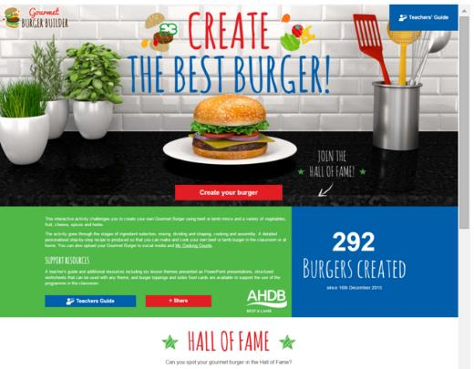

Introduction

The first hamburger was sold in America in the 1890s. No one can agree on who created it, though many lay claim to the title. Burgers are a popular quick service meal, with consumers wanting high quality burgers made with fresh ingredients, sourced from quality assured farms, available all year round.

The Gourmet Burger Builder has been designed to help students aged 11-16 to create imaginative, high quality and tasty burgers. The students are asked to select their choice of mince (beef or lamb). They will then be prompted to choose from a range of burger ingredients, including cheese, vegetables and fruit, sauces, herbs and spices.

Students decide how many burgers they wish to make and the activity then shows the burgers being divided, shaped and cooked. Students can also choose what they would like to serve their burger with – such as breads, sauces, cheese or bacon and salad. Food hygiene and safety tips are highlighted throughout the activity.

Finally, a personalised recipe is produced so that the student can make and cook their beef or lamb burger in the classroom or at home. The recipe highlights ingredients selected (including allergens), equipment, method, food hygiene and safety tips, food groups, skills demonstrated and nutritional information.

Learning objectives

Students will:
- create a burger using beef or lamb mince;
- recognise and understand that good food hygiene and safety is essential when making and cooking burgers, to ensure the food is safe to eat;
- calculate the nutritional content of their burger;
- list the ingredients that may cause an allergic reaction;
- be able to make and cook their burger, following personalised written instructions;
- demonstrate a variety of key food skills when making their burger in the classroom or at home.

How to use the Gourmet Burger Builder
Homepage  From the homepage, you can share the Gourmet Burger Builder via social media.  Teachers can download the Teacher’s Guide.  - To start, click ‘Create your burger’. | 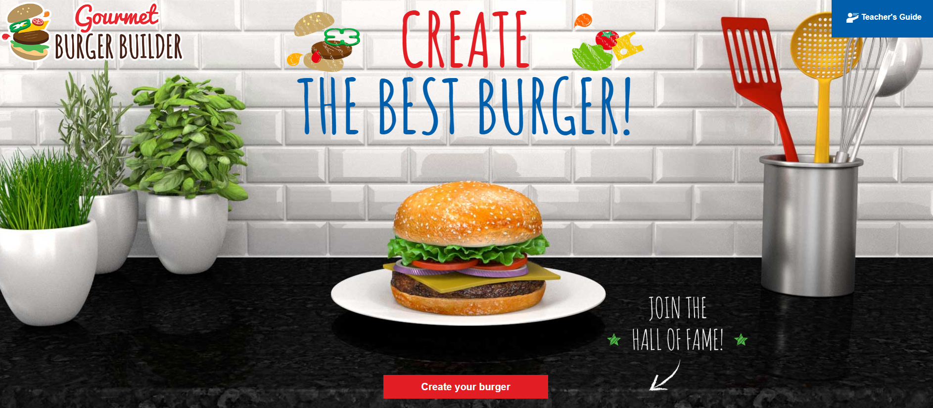
Food hygiene and safety tips  There is a ‘Food hygiene and safety tip’ for each stage of creating a burger.  Once you have read the tips, they can be minimised by selecting the icon on the right (-). | 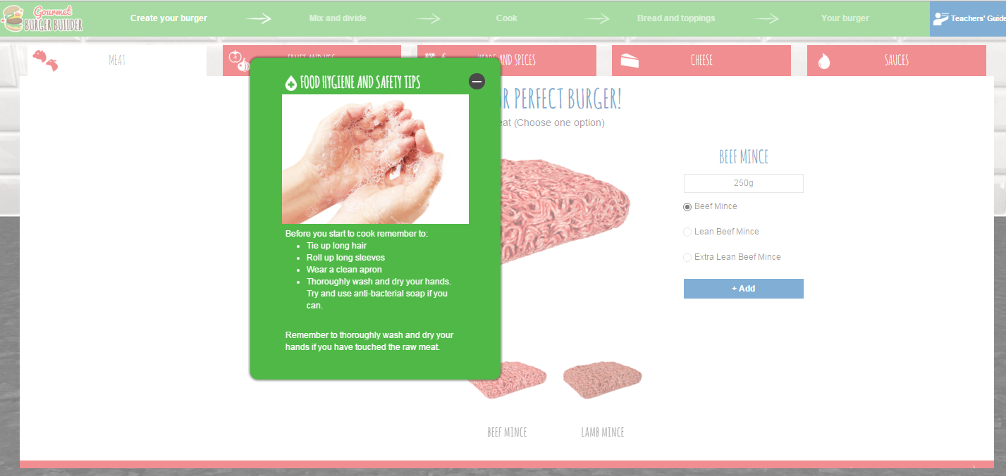
Meat  - Select beef or lamb mince and then the type. Click ‘Add’. You cannot move onto the next stage until you have selected beef or lamb  - To move onto the next stage, click on one of the red tabs (at the top) or ‘Fruit and Veg >’ (at the bottom)  - If you do not want to add any ingredients to the meat, click ‘Mix your burger’ (at the bottom). | 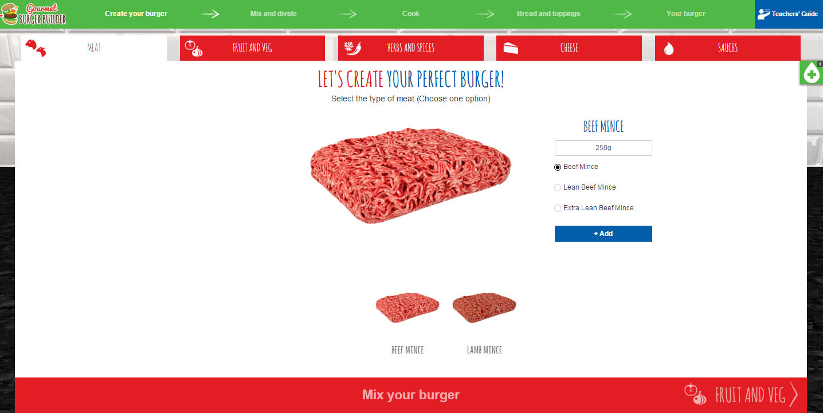
Fruit and Veg  - Use the left/right arrows to view all the different fruit and vegetables  - Select up to three fruit and vegetables, weighing up to 80g  - Adjust the amount of ingredients by selecting the + and - buttons  - Click ‘Add’ each time  - When the maximum number of ingredients/weight is selected, the remaining ingredients are ‘greyed out’  - Use the ‘Remove’ button to remove an ingredient  - To move onto the next stage, click on one of the red tabs (at the top) or ‘Herbs and Spices >’ (at the bottom)  - If you do not want to add any other ingredients to the meat, click ‘Mix your burger’ (at the bottom). | 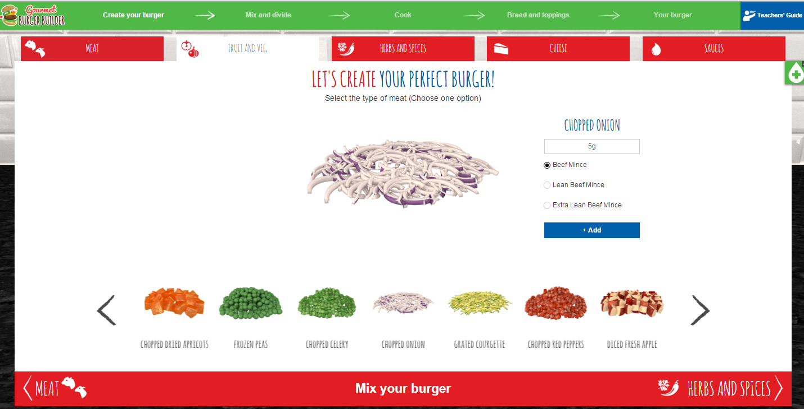
Herbs and Spices  - Use the left/right arrows to view all the different herbs and spices  - Select up to two herbs and spices. The quantity is pre-set and cannot be changed. Click ‘Add’ each time  - Use the ‘Remove’ button to remove an ingredient  - To move onto the next stage, click on one of the red tabs (at the top) or ‘Cheese >’ (at the bottom)  - If you do not want to add any other ingredients to the burger mixture, click ‘Mix your burger’ (at the bottom). | 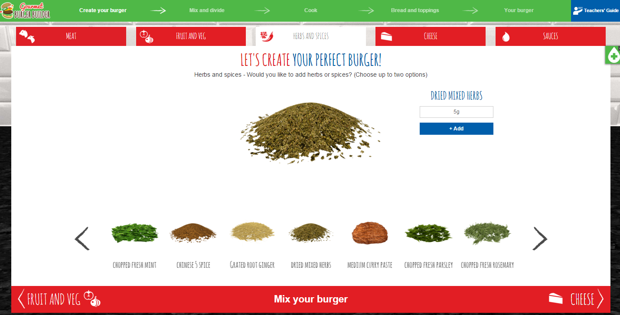
Cheese  - Use the left/right arrows to view all the different cheeses  - Select one type of cheese. The quantity is pre-set and cannot be changed. Click ‘Add’  - Use the ‘Remove’ button to remove an ingredient  - To move onto the next stage, click on one of the red tabs (at the top) or ‘Sauces >’ (at the bottom)  - If you do not want to add any other ingredients to the burger mixture, click ‘Mix your burger’ (at the bottom). | 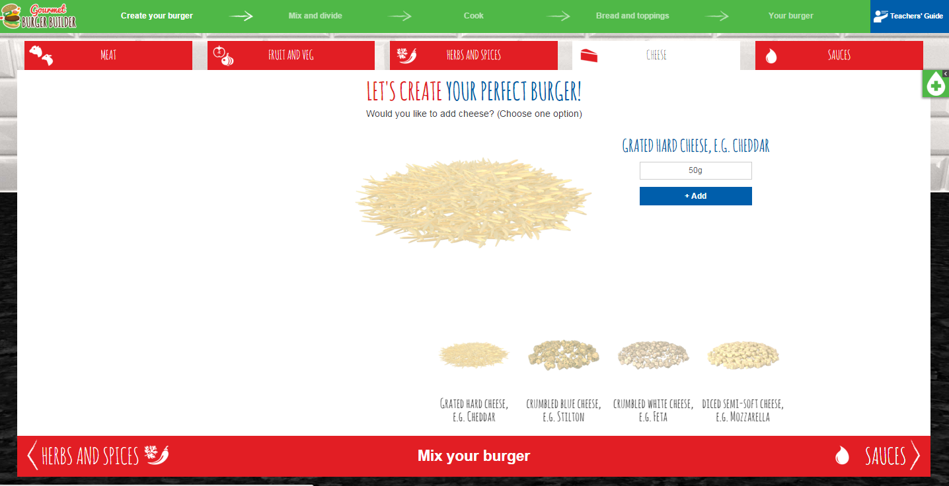
Sauces  - Use the left/right arrows to view all the different sauces  - Select one type of sauce. The quantity is pre-set and cannot be changed. Click ‘Add’  - Use the ‘Remove’ button to remove an ingredient  - Once you have added your sauce, click ‘Mix your burger’ or ‘Next >’ (at the bottom)  - If you do not want to add sauce to the burger mixture, click ‘Mix your burger’ (at the bottom). | 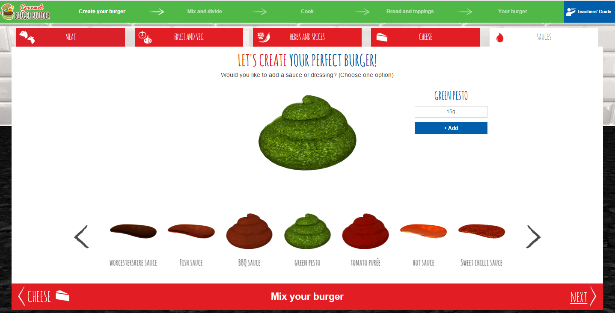
At this stage, a pop-up box appears to tell you that you will not be able to amend your burger if you progress.  - Select ‘No’ to remain on the same screen. You can then move back through the stages to amend your burger mixture recipe  - Select ‘Yes’ to move onto the mixing stage. | 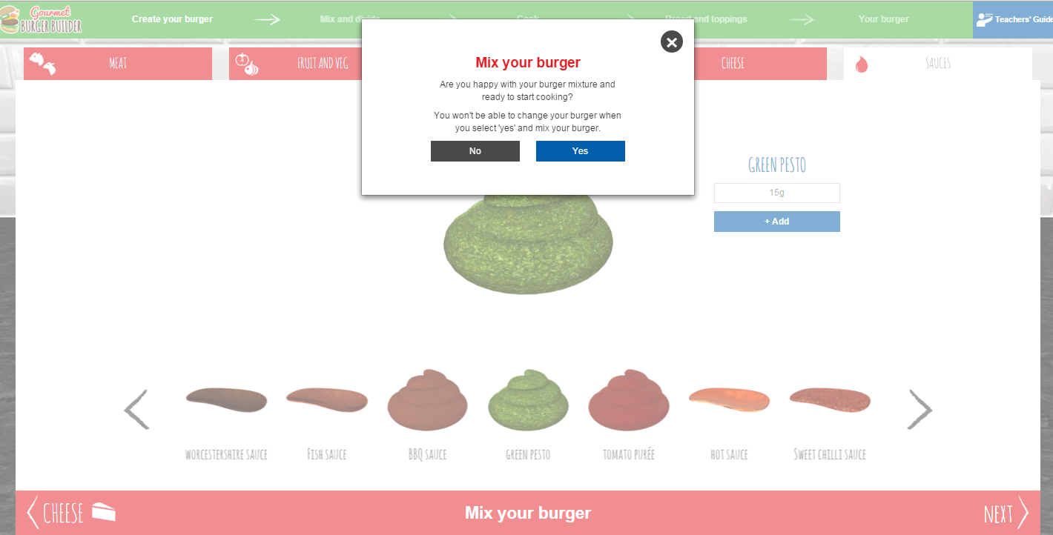
Mixing  Your burger ingredients will be mixed on the screen. | 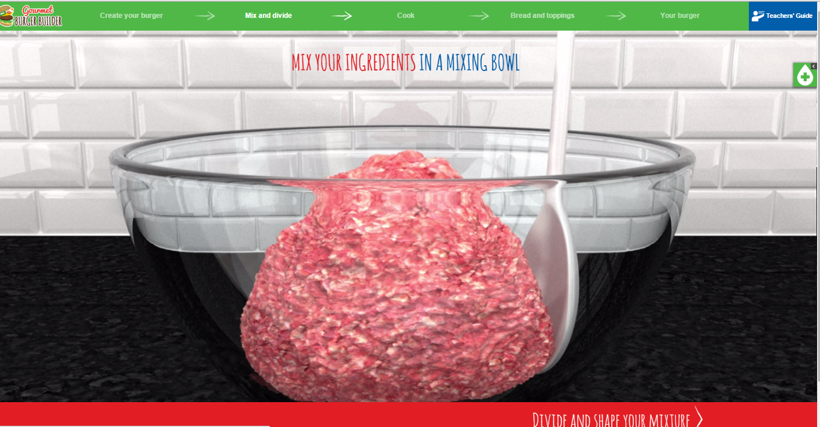
Divide and shape  - Select the number of burgers you would like to make (from 2 to 6)  - Click ‘Divide and shape your mixture’.  Your burgers are then divided and shaped.  - Click ‘Cook >’ (at the bottom). | 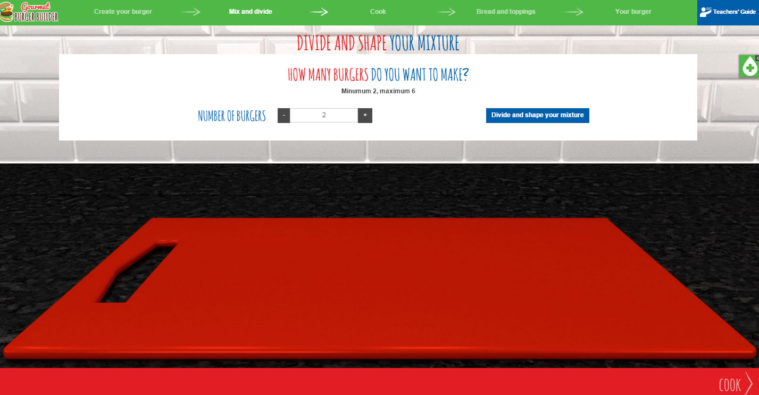  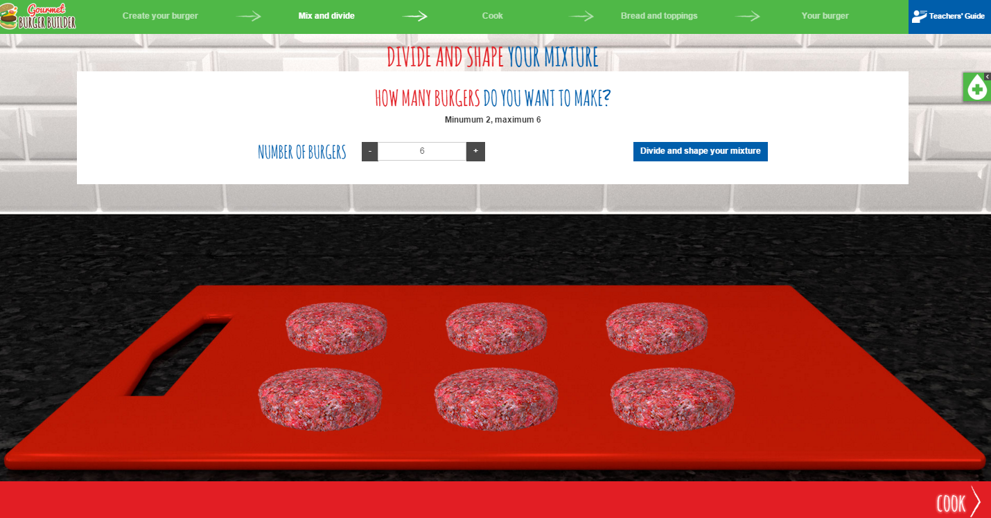
Cooking  Your burgers will then be cooked on the screen.  - Read the food hygiene tip and minimise using the icon on the top-left (+)  - Once your burgers are cooked, click ‘Bread and toppings >’ (at the bottom). | 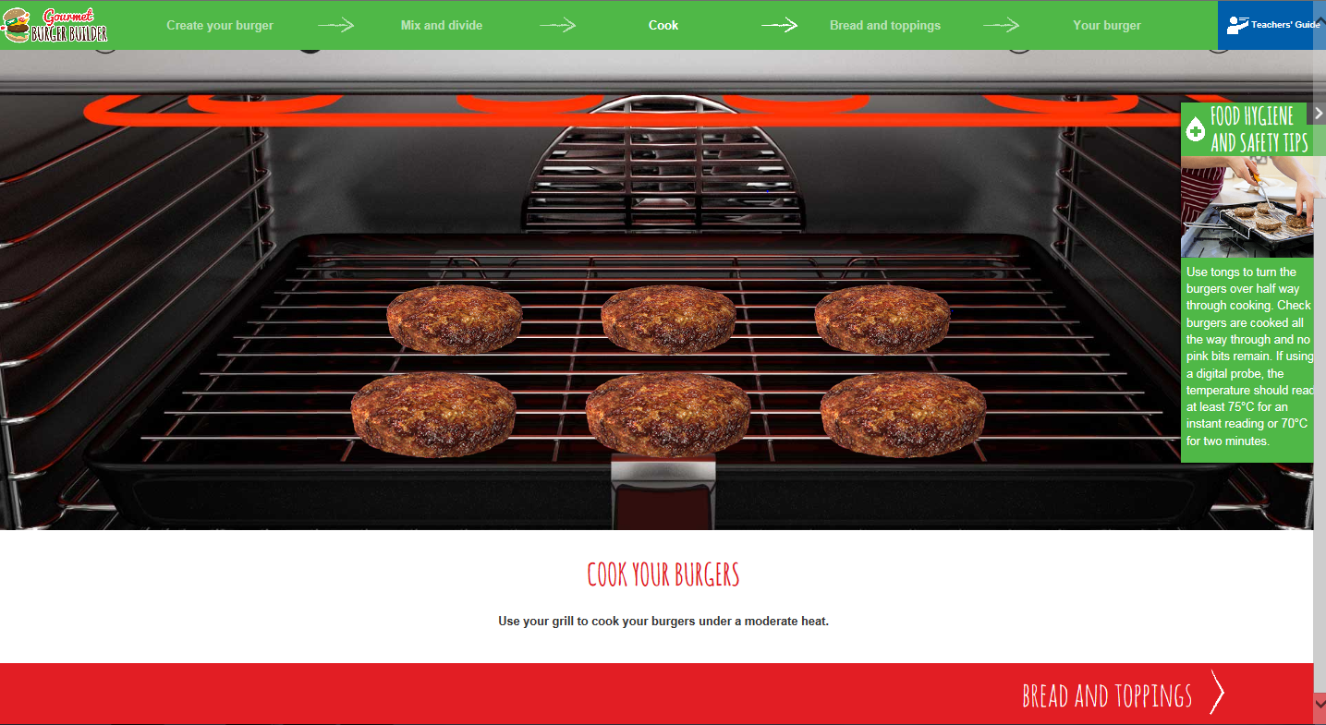
Bread  - Use the left/right arrows to view all the different bread  - Select one type of bread (or no bread). Click ‘Add’  - Use the ‘Remove’ button to remove an ingredient  - To move onto the next stage, click one of the red tabs (at the top) or ‘Salad >’ (at the bottom)  - If you do not want to add any toppings, click ‘Your recipe’ (at the bottom). | 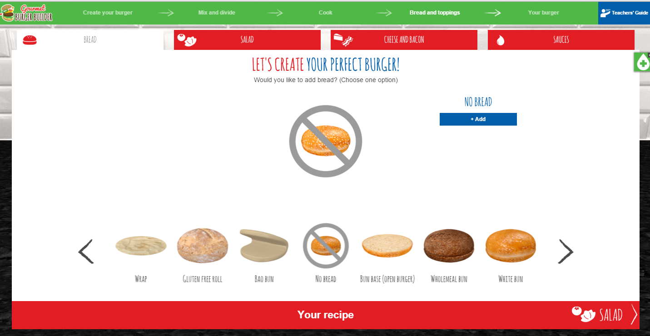
Salad  - Use the left/right arrows to view all the different salad items  - Select up to three salad items. Click ‘Add’ each time  - Use the ‘Remove’ button to remove an ingredient  - To move onto the next stage, click on one of the red tabs (at the top) or ‘Cheese and Bacon >’ (at the bottom)  - If you do not want to add any other toppings, click ‘Your recipe’ (at the bottom). | 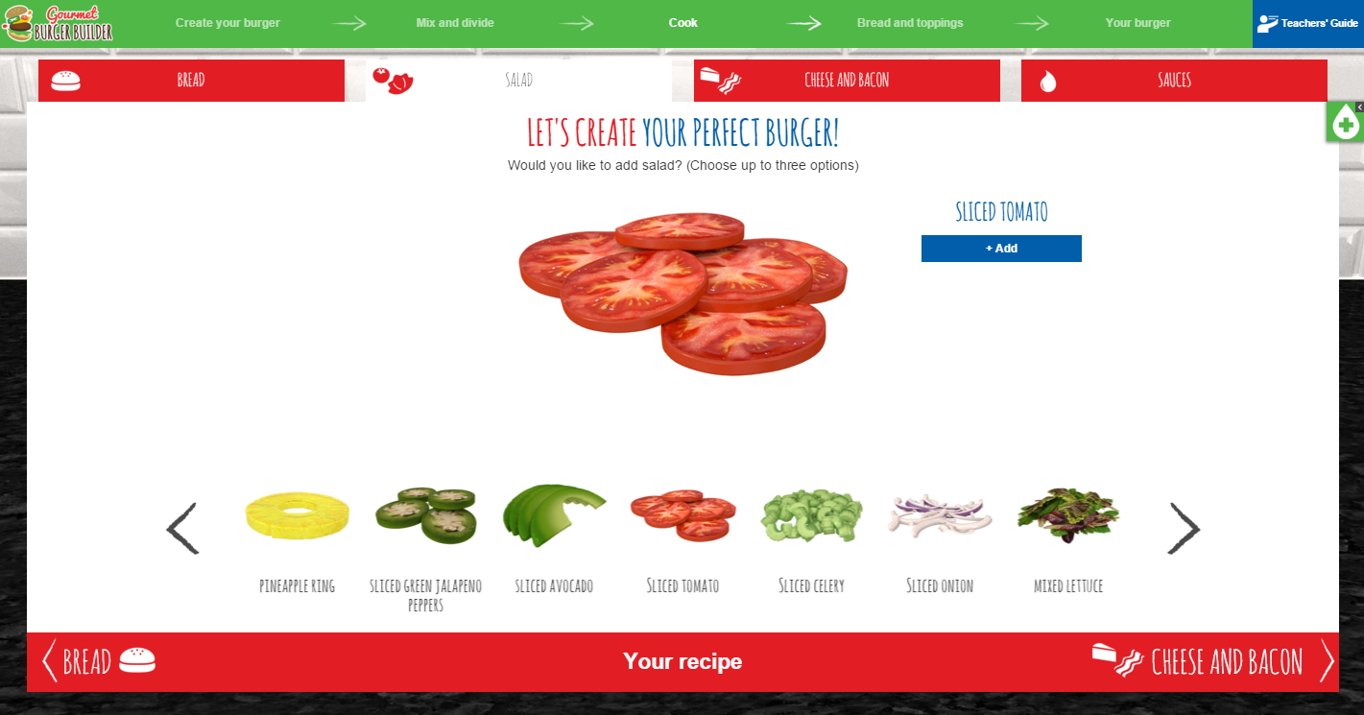
Cheese and Bacon  - Use the left/right arrows to view all the options  - Select the type of cheese or a rasher of bacon. Click ‘Add’  - Use the ‘Remove’ button to remove an ingredient  - To move onto the next stage, click on one of the red tabs (at the top) or ‘Sauces >’ (at the bottom)  - If you do not want to add any other toppings, click ‘Your recipe’ (at the bottom). | 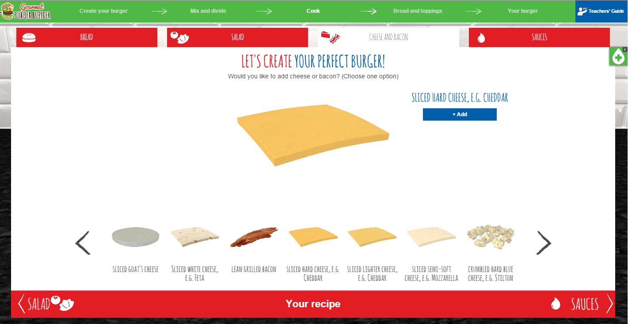
Sauces  - Use the left/right arrows to view all different sauces  - Select up to two types of sauces. Click ‘Add’ each time  - Use the ‘Remove’ button to remove an ingredient  - To move to the assembly of your burger, click ‘Your recipe’ or ‘Next >’ (at the bottom)  - If you do not want to add any sauces to your burger, click ‘Your recipe’ or ‘Next >’ (at the bottom). | 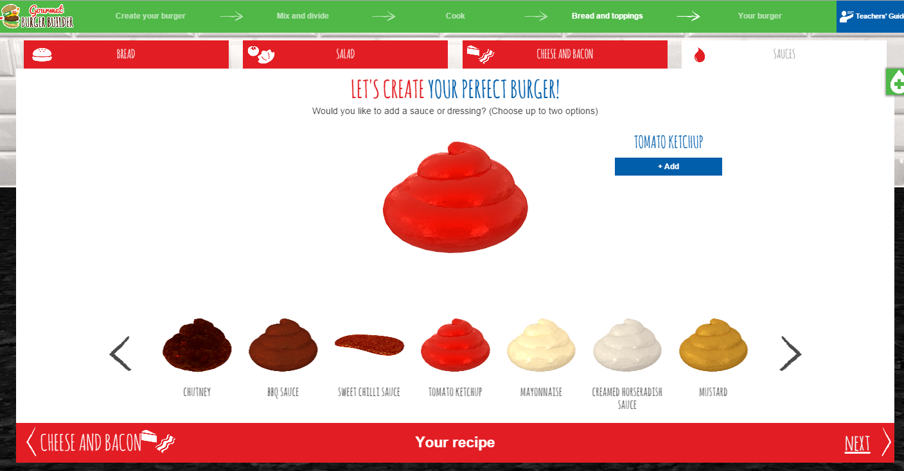
Your burger  At this point, you will be asked if you are ready to assemble your burger.  - Select ‘No’ to remain on the same screen. You can then move back through the stages to amend your breads and toppings  - Select ‘Yes’ to move onto the assembly stage. | 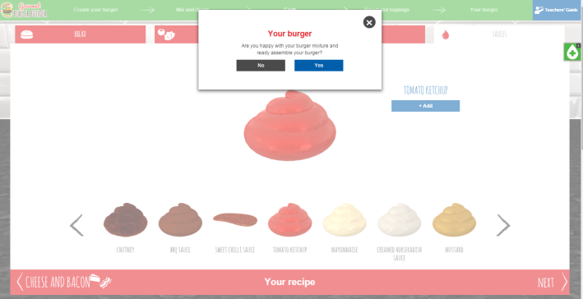
Name your burger  - Name your burger and click ‘Add’.  - Click ‘Share’ to share your Gourmet Burger on Facebook, Twitter or Pinterest  - To move onto the next stage click ‘Your recipe >’ (at the bottom). | 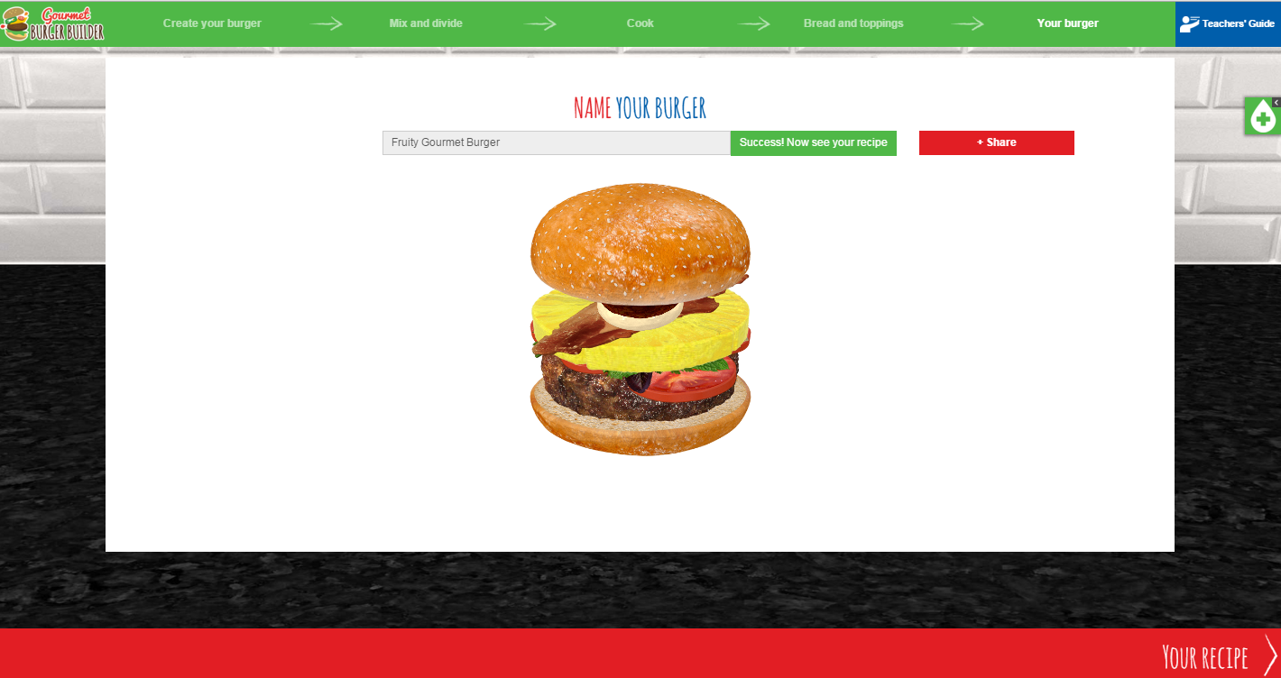
Your recipe  Your recipe includes ingredients selected, allergens, equipment, method, food hygiene and safety tips, food groups, skills used and nutritional information.  - Use the buttons at the top to print your recipe, export and save it as a PDF. | 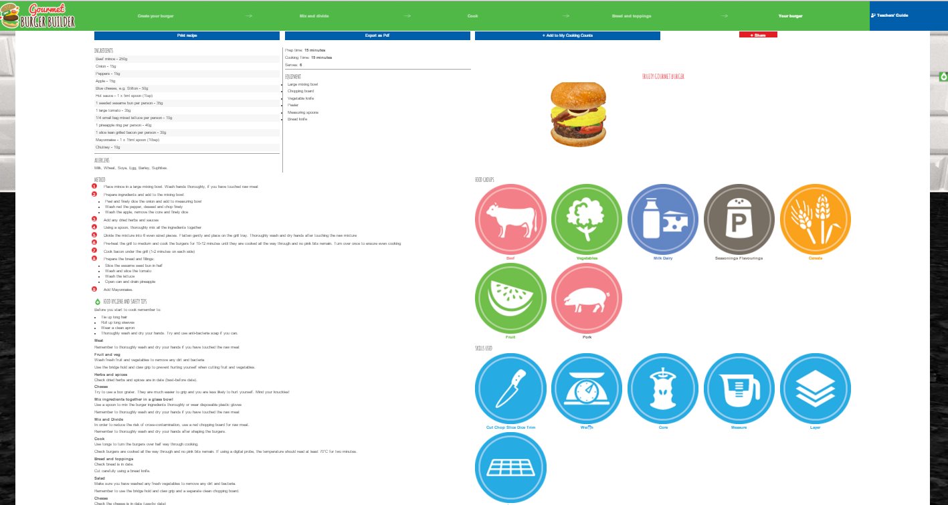

Ideas for the classroom
There are a variety of ways in which Gourmet Burger Builder could be used. For example, students could create several burgers and compare nutrition information, e.g. reduce fat or increase fibre, or make burgers with a multicultural flavour. A number of lesson ideas and worksheets have been developed to support the use of Gourmet Burger Builder and can be found on the Food – a fact of life website.

Gourmet Burger Builder can be used on a computer, tablet or smart phone. Therefore, it is ideal for use in schools or set as homework.

Encourage students to print their work – a great ‘burger’ display could be created. Their work can also be exported as a ‘pdf’, which they can save (as evidence of their work).

Lesson ideas and themes
There are six lesson themes presented as PowerPoint presentations to stimulate creativity, independent learning and class discussion. The themes are:
- Fusion Food
- Party Time!
- Eat With Mates!
- Veg Out!
- The BBQ
- Posh Nosh!
Each PowerPoint presentation challenges the students to create a burger following a particular theme or trend. Relevant short activities are also included, along with images to inspire and promote creativity.

Structured worksheets
There are eight worksheets that can be used with any theme. The worksheets can be used as a classroom activity, independent study or set as homework.
Worksheets/activities include:
- Be Creative!
A creative task that challenges students to identify ingredients from different cuisines and cultures that could be used to make a ‘fusion’ burger.
- Burger Modification Challenge
A three-stage task focusing on the nutritional content of burgers and identifying ways to reduce total fat content or increase the fibre and Vitamin C.
- Food Provenance
A task to investigate the key features of the Red Tractor and Quality Standard Beef & Lamb quality assurance schemes.
- Burger Safety
A worksheet to identify the steps taken to ensure food is safe to eat.
- Burger Production Plan
A process chart to identify the procedures necessary to ensure that a student’s burger is safely and hygienically made and of a high quality.
- Understanding Allergens
A worksheet to assess knowledge and understanding of the 14 allergens that must appear on a food label (if the ingredient appears).
- Sensory Evaluation
A variety of worksheets to enable effective sensory evaluation.
Food cards
There is also a downloadable pack of food cards, displaying the energy provided by 100g, to use as part of active learning, e.g. being creative with ingredients used in the burger mix or toppings and sides.

Further resources
The following resources to support teaching and learning are all available on the Food – a fact of life website:

Meat
- This is meat
- Meat types and cuts
- Meat storage and preparation
- Meat and the consumer

https://www.foodafactoflife.org.uk/11-14-years/food-commodities/meat/

Food hygiene

https://www.foodafactoflife.org.uk/11-14-years/cooking/hygiene-and-safety/

Downloadable posters

https://www.foodafactoflife.org.uk/11-14-years/food-commodities/meat/posters/



