Black bean and red pepper shakshuka

Ingredients
Complexity: medium-high
2 red peppers
1 large onion
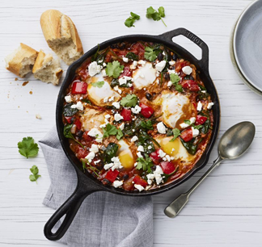
4 garlic cloves
50g spinach leaves or kale
2 x 15ml spoons oil
1 x 5ml spoon cumin
2 x 5ml spoons (heaped) paprika
½ x 5ml spoon chilli powder
2 x 400g cans chopped tomatoes
1 x 400g can black beans
6 eggs

Optional - garnish
30g coriander
30g feta cheese – garnish

Equipment
Chopping board, vegetable knife, garlic press, large sauté/frying pan, mixing spoon, measuring spoons, can opener, sieve/colander.

Method
- Prepare the ingredients:
- deseed and dice the red peppers;
- peel and dice the onion;
- peel and finely chop or crush the garlic;
- wash and roughly chop the spinach or kale;
- chop the coriander.
- In a large frying pan heat the oil.
- Add the diced peppers and onion and cook for 5-7 mins until softened.
- Add the chopped garlic, cumin, paprika and chilli powder to the pan. Cook for 3 minutes stirring.
- Drain and rinse the black beans. Add the chopped tomatoes and black beans to the pan and mix.
- Simmer uncovered on a medium heat for 7-10 minutes.
- Stir in the spinach leaves or kale.
- Make 6 small wells in the sauce evenly spaced around the pan. Crack 1 egg into each of the wells.
- Cover the pan and cook for 8-10 minutes.
- Garnish with the chopped coriander and crumbled feta cheese.

Top tips
- Try using different types of beans such as red kidney or borlotti.
- Use canned tomatoes with herbs or chilli for extra flavour.
- Have the recipe for a smaller portion.

Food skills

- Weigh
- Measure
- Cut
- Dice
- Peel
- Chop
- Crush
- Fry/Sauté
- Mix and stir
- Simmer

Did you know?

Shakshuka is said to have originated in Ottoman in North Africa in the mid-16th Century after tomatoes were introduced to the region. The word Shakshuka is a Maghrebi Arabic term meaning ‘mixture’ or ‘mixed up’. There are many variations to the basic sauce with ingredients such as olives, harissa, spicy sausage or soft cheese all adding different flavour and texture. It is often served with crusty bread for dipping into the eggs!

In Jewish culture, a large batch of tomato stew is made for the Sabbath dinner and the leftovers used the following morning to make a breakfast shakshuka with eggs.

This recipe was kindly donated by Asda Stores Limited.

