The digestive system
Do you know the body parts involved in the digestion process?

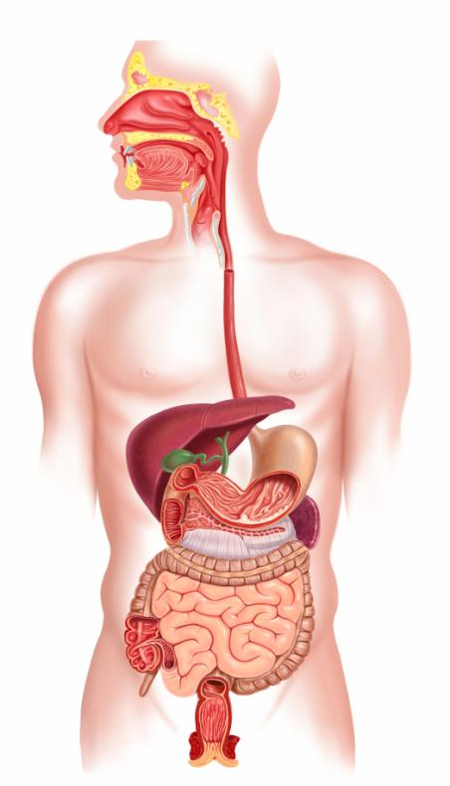
Link the body part name to the correct part of the body.
Stomach
Teeth
Mouth
Small intestine
Oesophagus

