

In groups, task the pupils to review the dish card they have been assigned.

Challenge them to re-design the meal to promote the key messages of The Eatwell Guide and 8 tips for healthy eating.

Steak, eggs, toast and tea

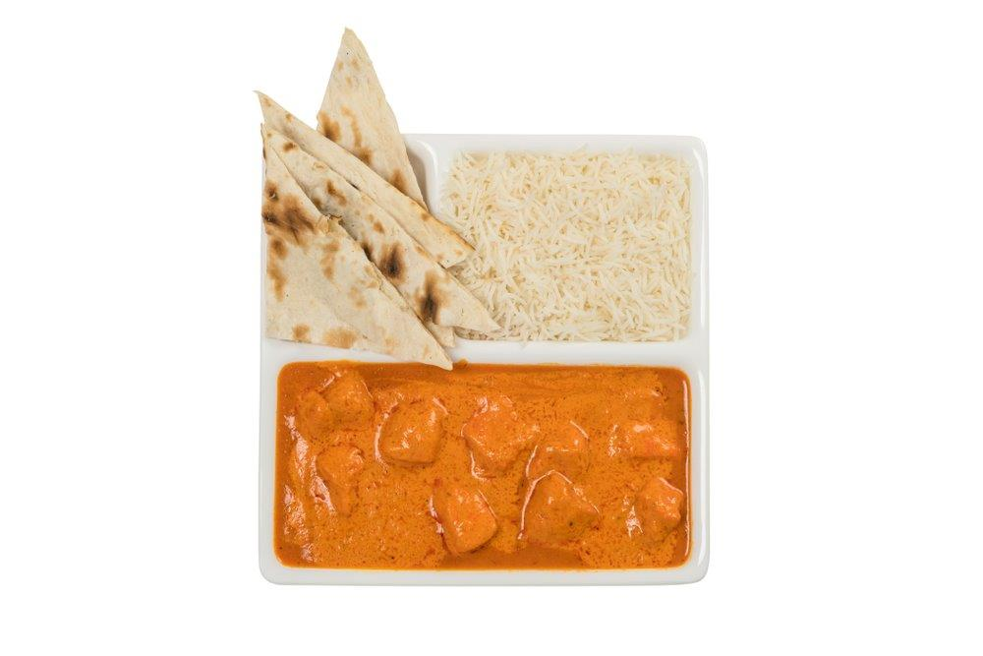
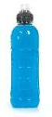

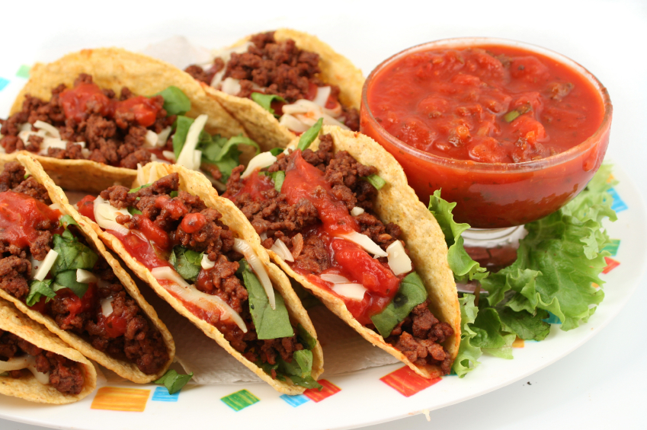

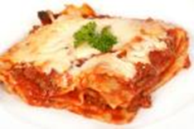
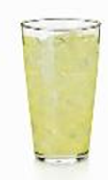
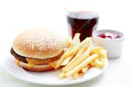
This card has been left intentionally blank
Indian butter chicken and water
Beef tacos and orange juice
Burger, chips and fizzy drink
Lasagne and lemonade
Pizza and sports drink

