Dutch apple cake
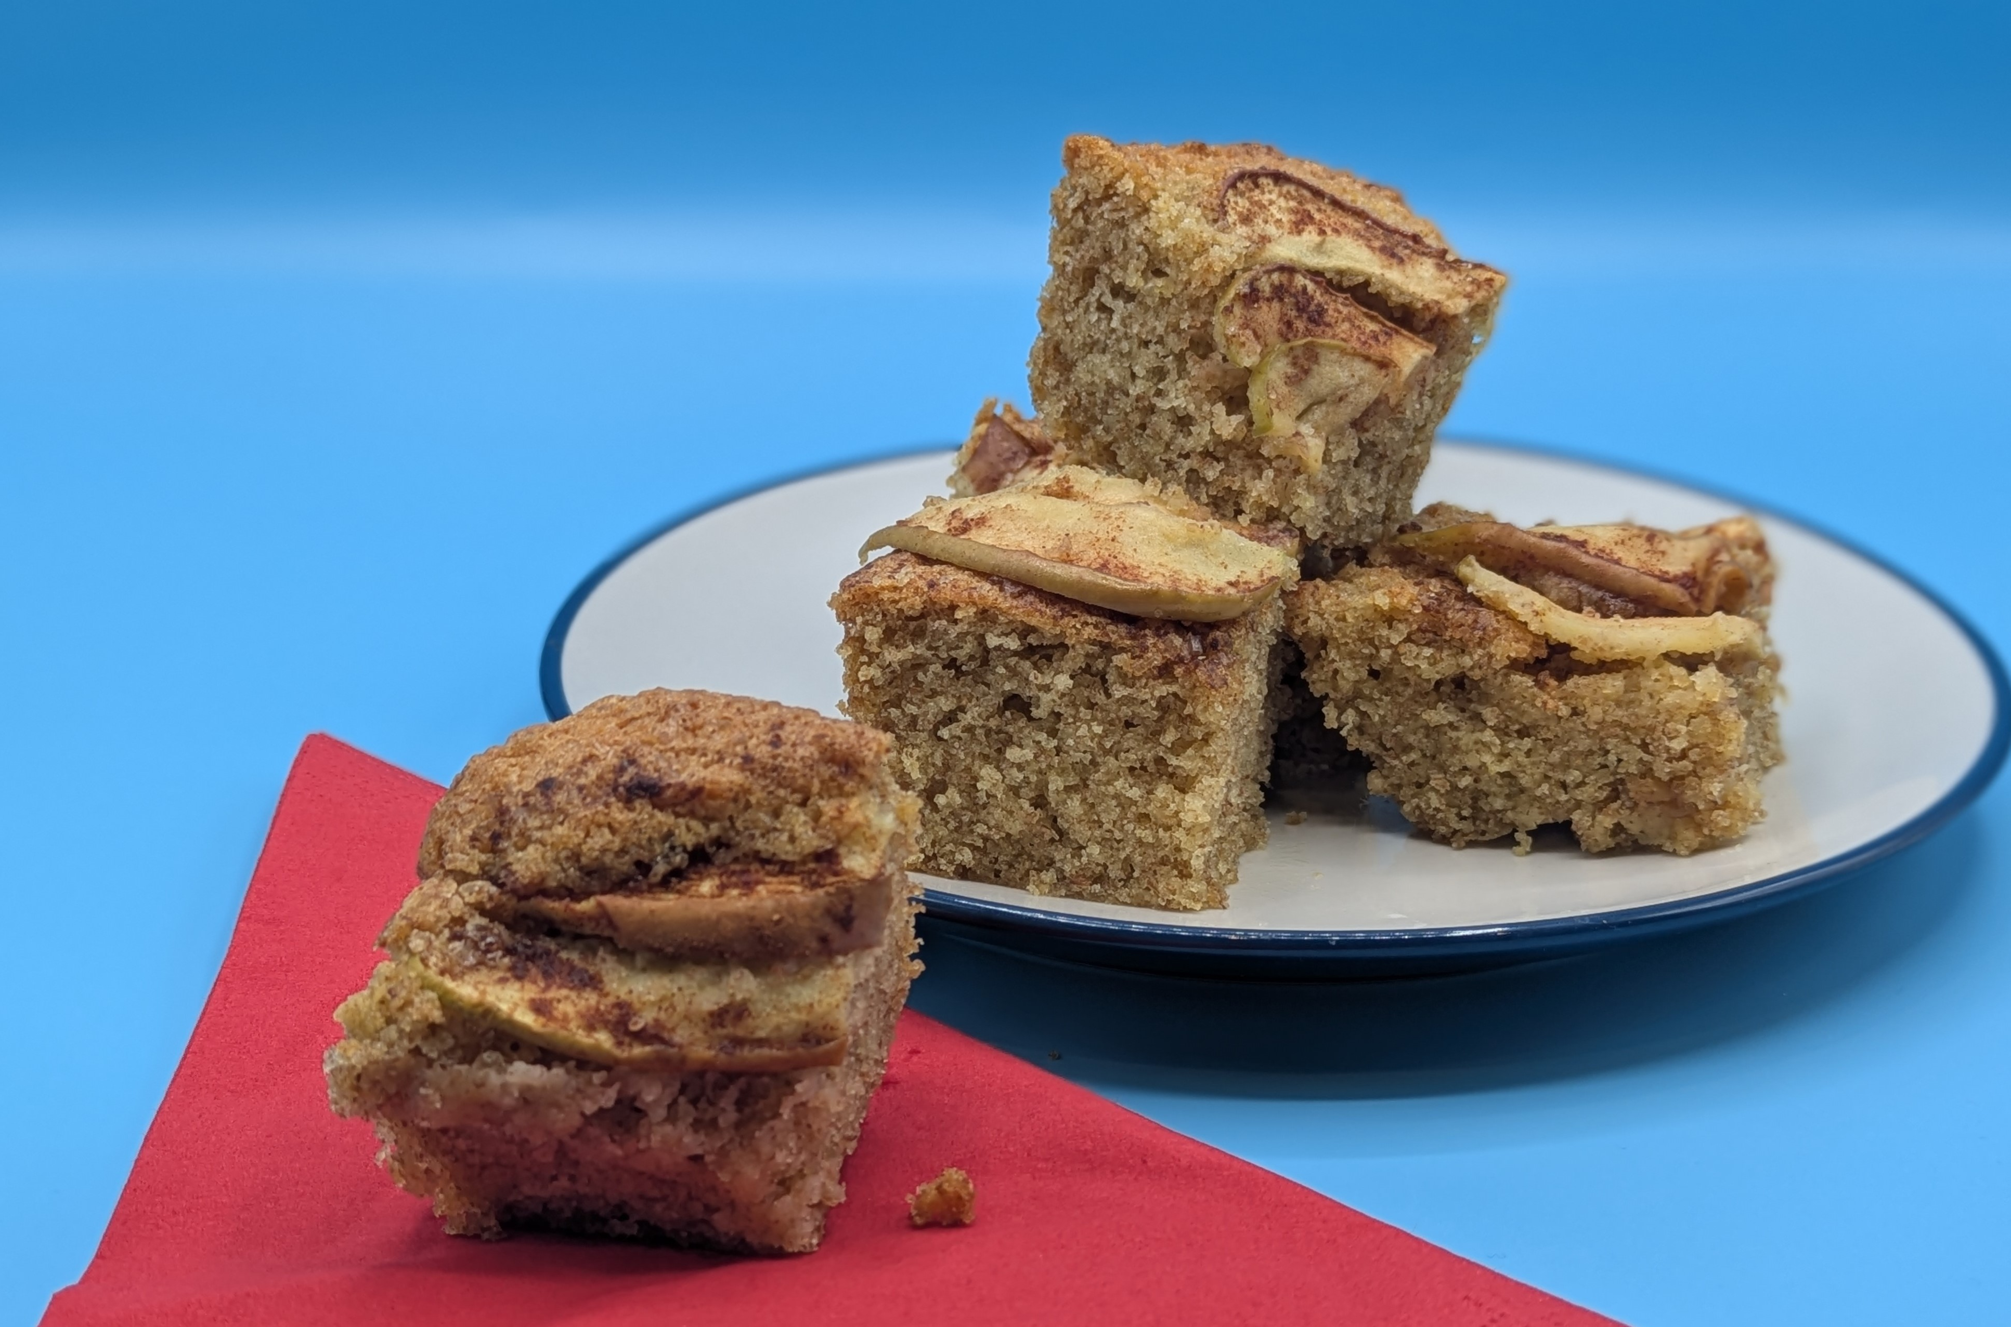
Complexity: medium
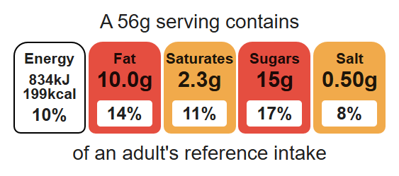

Ingredients (makes 8)
100g caster sugar

Equipment

Weighing scales

Baking tin (20cm square) or foil trays

Electric hand whisk

Mixing bowl

Small bowl

Sieve

Metal spoon

Sharp knife

Chopping board

Spatula

Measuring spoons

Cooling rack

100g reduced-fat spread
2 eggs
50g self-raising white flour
50g self-raising wholemeal flour
1 x 5ml spoon baking powder
1 eating apple
½ x 5ml spoon cinnamon
1 x 5ml spoon demerara sugar

Method
- Preheat the oven to 180ºC or gas mark 4.
- Grease or line the baking tin or foil trays.
- Cream the caster sugar and fat together, ideally using an electric hand whisk, until light and fluffy.
- In a small bowl, crack and beat the eggs with a fork.
- Add the beaten egg, a little at a time, to the fat and sugar.
- Sift the flour and baking powder into a bowl, or onto a plate or piece of greaseproof paper.
- Fold the flour and baking powder into the mixture, a spoonful at a time.
- Spread the mixture in the cake tin.
- Core the apple on a clean chopping board and slice thinly.
- Arrange the apple slices over the cake mix, then sprinkle the cinnamon and demerara sugar on top.
- Place in the oven and bake for around 20 minutes, until golden brown and springy to the touch.
- Remove from the oven and allow to cool.

Top tips
- Turn up the flavour: For a tasty alternative try pear and ginger.
- Reduce food waste: Use up any leftover fruit in your cake.
- When lining the baking tin, it is only necessary to line the bottom of the tin. The sides can be greased with oil.

Food skills
Weigh, measure, cream, beat, sift, mix, stir and combine, fold, core, cut, chop, slice, dice and trim, bake.

