Food price and food choice

- Look at the FAO data regarding food price indices below.
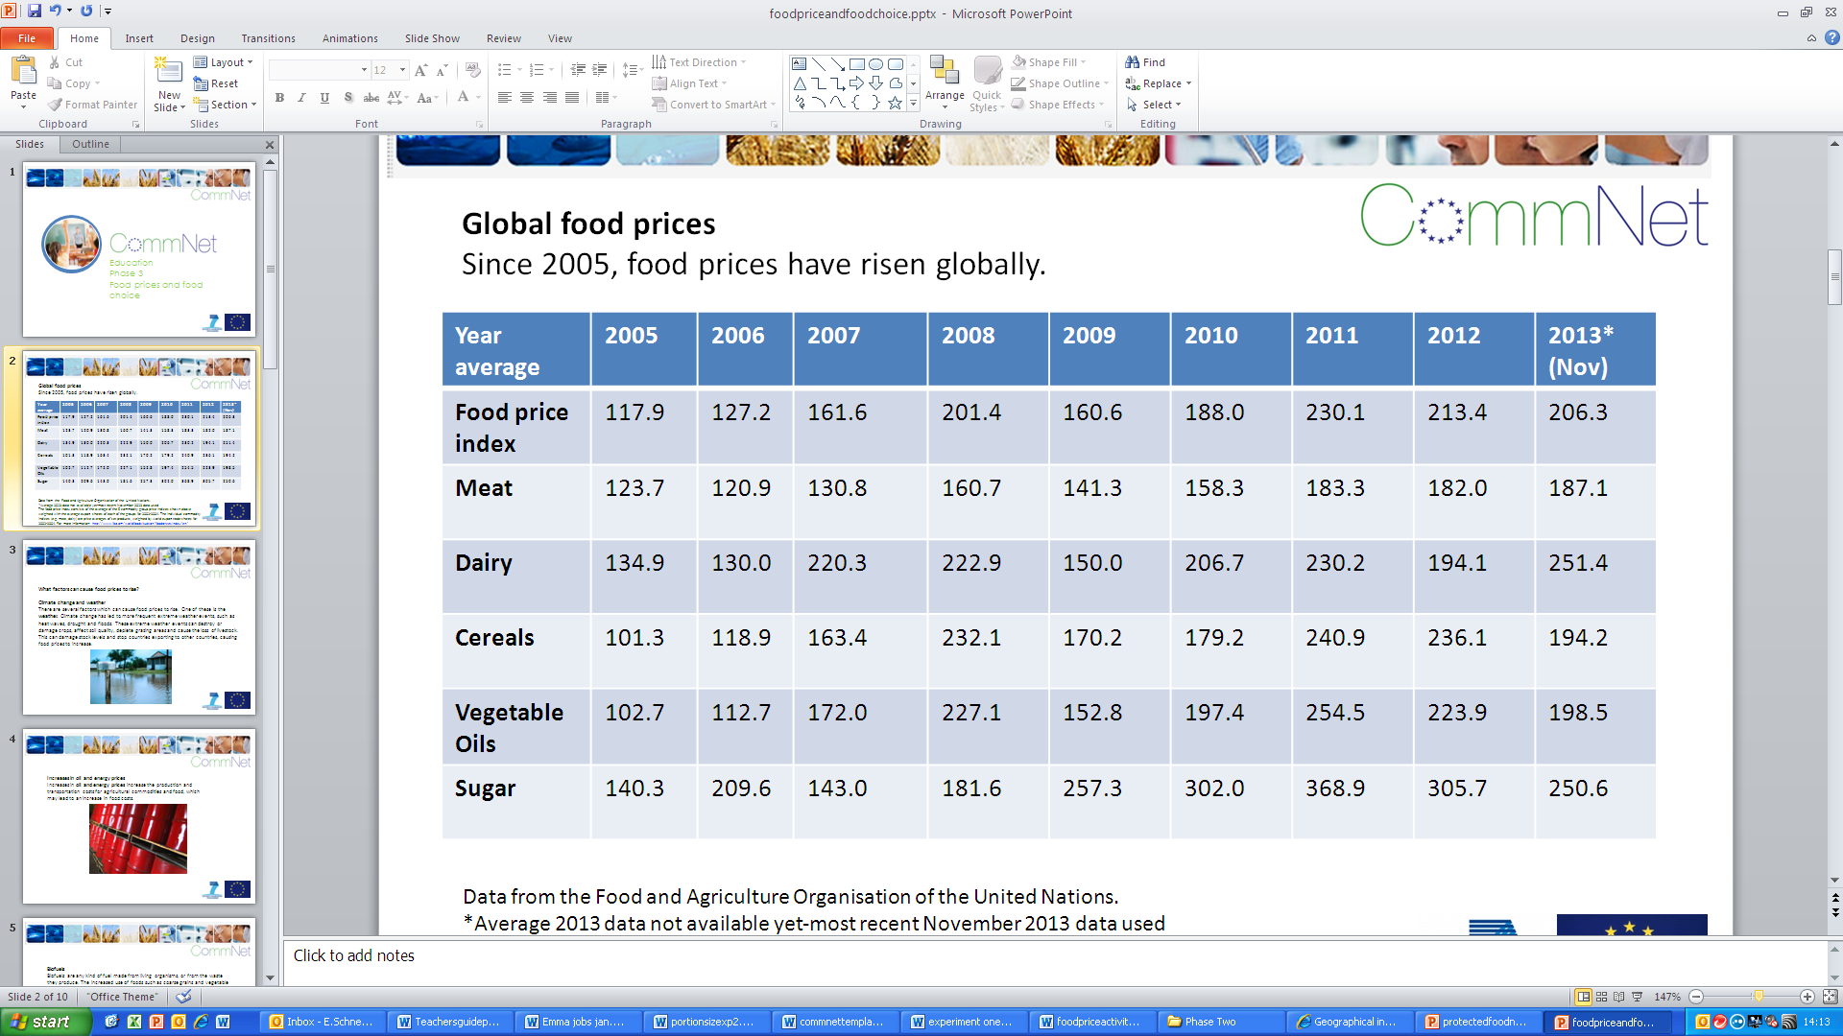

- Describe the trends occurring to the food price index and individual food commodity indices from 2005 to 2013.
- Which food commodities have increased in price the most?
- Which food commodities have increased in price the least?
- Have there been any major price spikes in this time period?
- Draw a graph to help illustrate your answer.

- One strategy to reduce the amount of money spent on food would to be choose different types of food.
- With a budget of £20 plan what food and drink you would buy to feed yourself for a week.
- Visit a supermarket or use online supermarket pricing information to record the prices of the food and drink you have planned to buy.
- Document the plan and the prices.

- Now imagine the price of food and drink has risen by 10% but your budget remains £20.
- Are there any food and drinks you can no longer afford to buy?
- Would you make any swaps?
- What changes will this make to the quality of your diet?

