Estimating and weighing

Read the back-of-pack nutrition label on the breakfast cereal box. Complete the following table:
Nutrient | Fat (g) | Sugar (g) | Vitamin D (µg) | Iron (mg) | Folate/folic acid (µg)
Amount per 100g
Amount per recommended portion (…….g)

How much cereal was in your portion? _____g

Calculate the difference between your portion size and the manufacturer’s portion size recommendation (given on the box) of the following nutrients. You will need a calculator for this activity.

Nutrient | Fat (g) | Sugar (g) | Vitamin D (µg) | Iron (mg) | Folate/folic acid (µg)
Amount in your portion (…….g)
Amount per recommended portion (…….g)
Difference in nutrient between your portion size and the recommended portion size

Portion size guidance at BNF
The portion size guidance from the BNF suggests that three handfuls of breakfast cereal is an average portion size (40g).

Put three handfuls of breakfast cereal in a bowl. How much does this weigh?
………..g

Ask two other people to complete the activity and compare the results.

Portion size (g)
Person 1

……………………………

Person 2

……………………………

Person 3

……………………………

Reflections …
__________________________________________________________________________________________________________________________________________________________________________________________________________________

Note: The BNF guidance is based on the needs of an adult woman.

Pasta
Pour out how much dried pasta you would cook for yourself for a main meal into a bowl.

How much does it weigh?
…….g

The BNF portion size recommendation for dried pasta is 75g. Using the nutrition information on the pasta pack, calculate the difference in the energy provided by the two portions.

Energy (kj / kcals)
Amount in your portion (…….g)
Amount per recommended portion (75g)
Difference in energy (kcals) between your portion size and the recommendation
See the tip on the last sheet for help on how to do this.

Rice
Pour out how much dried rice you would cook for yourself for a main meal into a bowl.

How much does it weigh?
…….g

The BNF portion size recommendation for a portion of dried rice is 65g. Using the nutrition information on the rice pack, calculate the difference in the energy provided by the two portions.

Energy (kj / kcals)
Amount in your portion (…….g)
Amount per recommended BNF portion (65g)
Difference in energy (kcals) between your portion size and the recommendation

Note: The BNF guidance is based on the needs of an adult woman.

Fruit/vegetable juice and smoothies
Using water or coloured water, pour a portion of fruit/vegetable juice or smoothie into a glass.

Measure how many ml were in your portion?

……….ml

The recommendation from the Eatwell Guide is that we should not consume more than 150ml of fruit/vegetable juice and smoothies each day in total.

Using the information on the label below, calculate the difference in sugars between your portion and the recommended portion size of 150ml. Write your results in the table.

Sugars (g)
Amount of sugars in your portion (…….g)
Amount of sugars per recommended portion (150ml)
Difference in sugars between your portion size and the recommended portion size
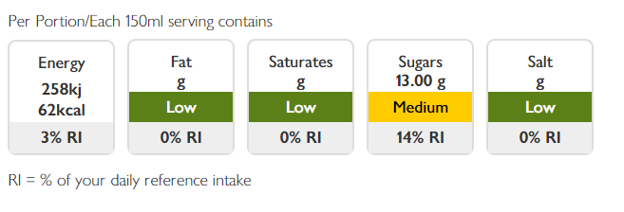
Tip
To work out the amount of a nutrient in a portion, divide the amount of each nutrient by the portion size you are calculating. This will give you the amount per 1 gram or ml. Then you can multiply this by the total grams or ml in your portion.

Worked example:

If there is 10g of sugar in 100ml of fruit juice, how much is in 150ml?
10/100 = 0.1
0.1 x 150 = 15g sugar per 150ml
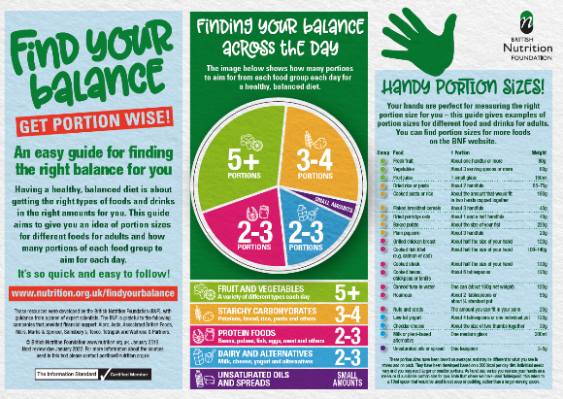

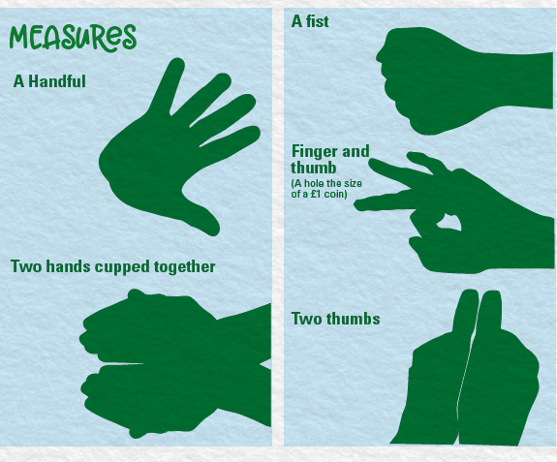

For more information about portion sizes, go to www.nutrition.org.uk

