Nutrient comparison exercise

- Measure the quantities of sugars and/or fat provided by the following food and drinks.
- Compare the front-of-pack label amounts to the reference intake.
Reference Intakes are guidelines for the maximum amount of energy (calories), fat, saturated fat, sugars and salt we should have in a day (based on a healthy adult female).

- What conclusions do you make?
Energy or nutrient | Reference Intake
Energy | 8400kJ/ 2000kcal
Total fat | 70g
Saturates | 20g
Carbohydrate | 260g
Sugars | 70g
Protein | 50g
Salt | 6g

Salami stick mini – 10g
Diet cola
Salt and vinegar crisps - baked

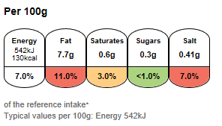
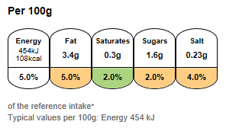

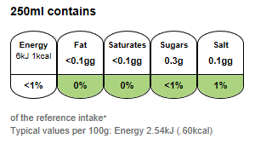
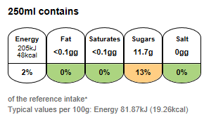

Regular cola
Diet cola
Regular cola

Salt and vinegar crisps - baked
Salt and vinegar crisps

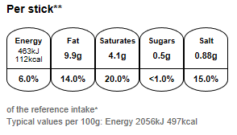
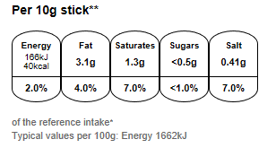

Salami stick mini -10g
Salami stick – 22.5g

Nutrient comparison exercise continued

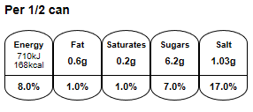
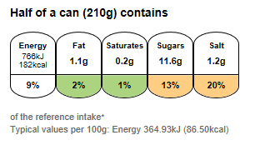

Baked beans in tomato sauce, reduced salt and sugar
250ml contains
250ml contains
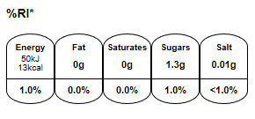
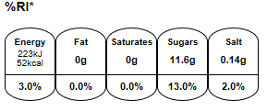
Corn flakes breakfast cereal
Baked beans in tomato sauce
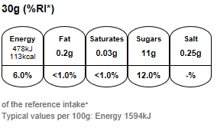
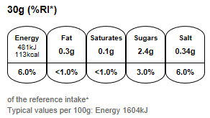
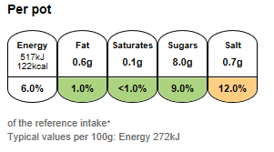

Frosted flakes – breakfast cereal
Pasta shapes in tomato sauce, 190g pot
Pasta and tomato sauce snack pot, made with water
Frosted flakes – breakfast cereal
Pasta shapes in tomato sauce, 190g pot
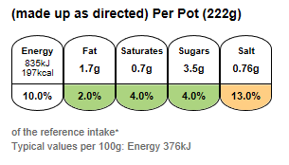
Blackcurrant drink, ready to drink
Light blackcurrant drink, ready to drink

