Comparing the label
Use Explore food to answer the questions below: http://explorefood.foodafactoflife.org.uk/
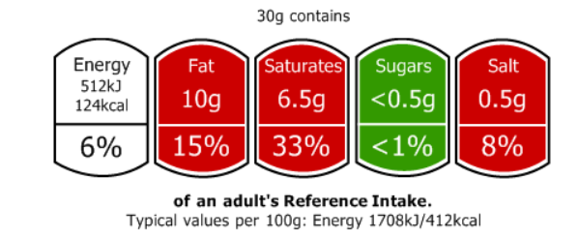
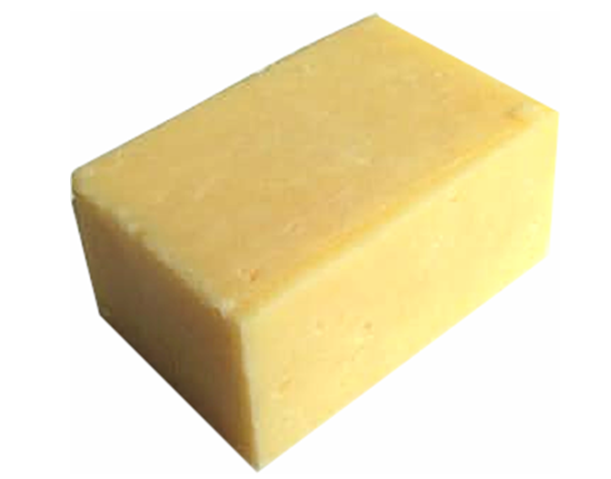
- Cheddar cheese

Using Explore food, find:
- a cheese which is lower in fat than the Cheddar cheese above.
Name of cheese:____________________________
g of fat: ___________per 30g
- a cheese which is lower in saturated fat than the Cheddar cheese above.
Name of cheese:____________________________
g of saturated fat: ___________per 30g
- a cheese which is lower in salt than the Cheddar cheese above.
Name of cheese:____________________________
g of salt: ___________per 30g
Print and attach the front of pack labels of your findings to this worksheet.

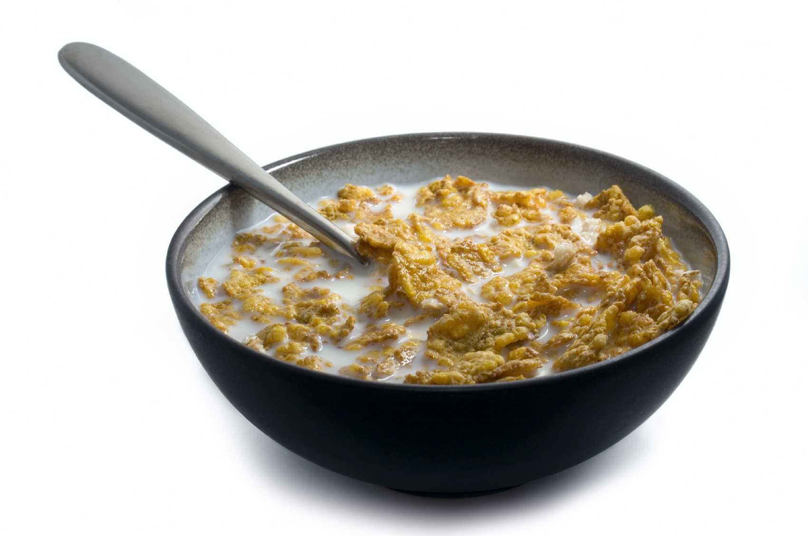
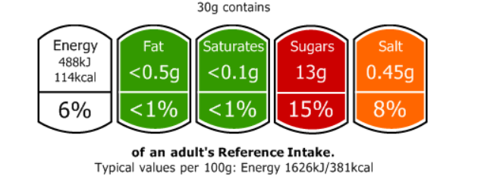
- Sugar coated cornflakes (without milk)

Using Explore food, find:
- a cereal that is lower in sugar than the sugar coated cereal above.
Name of cereal:____________________________
g of sugar: ___________per 30g
- a cereal which has a green (low) level of sugar.
Name of cereal:____________________________
g of sugar: _____________per 30g
- a cereal that is lower in salt than the sugar coated cereal above.
Name of cereal:____________________________
g of sugar: ___________per 30g
Print and attach the front of pack labels of your findings to this worksheet.

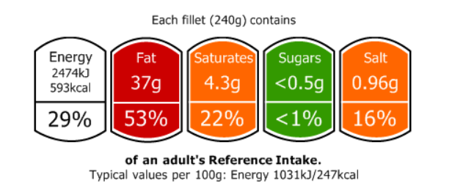
- Cod in batter (fried in sunflower oil)
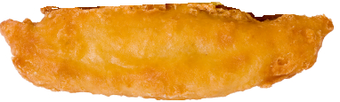
Using Explore food, find:
- a way of preparing and cooking a cod fillet which is lower in fat than the oven baked cod in batter above.
Preparation and cooking methods:____________________________
g of fat: ___________per 240g
- Create and compare the labels of a 140g fillet of white fish and a 140g fillet of oily fish. What are the major differences to the nutrients on the label? Explain the nutritional benefits of eating oily fish.
- Create and compare the labels of 140g smoked and 140g of unsmoked fish.
Print and attach the front of pack labels for your findings to this worksheet.

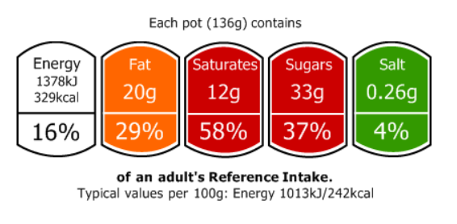
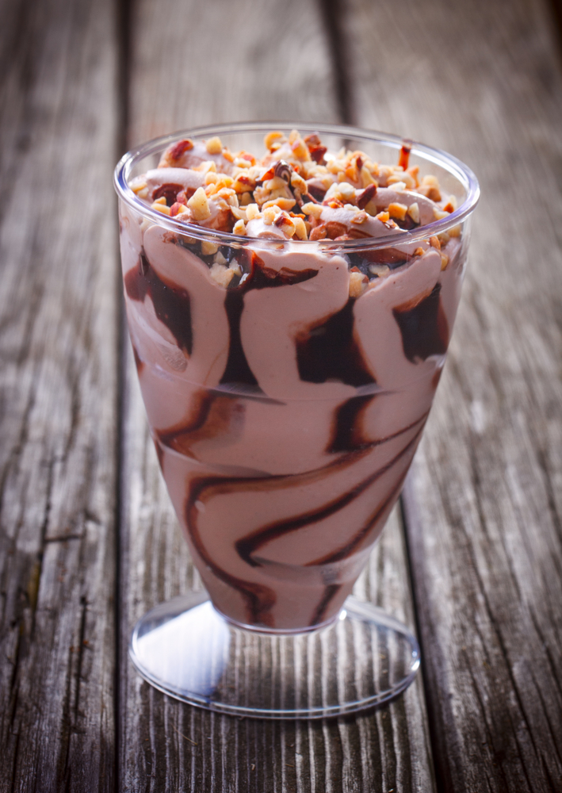
- One pot (136g) of chocolate nut sundae

Using Explore food, find:
- a dessert which is lower than fat than the chocolate nut sundae
Name of dessert:________________________
g of fat:__________per 136g
- a dessert which is lower in saturated fat than the chocolate nut sundae.
Name of dessert:________________________
g of saturated fat: __________per 136g
- a dessert which is lower in sugar than the chocolate nut sundae.
Name of dessert:________________________
g of sugar:___________per 136g
- a dessert which contributes towards your 5 A DAY.
name of dessert: _________________________
Print and attach the front of pack labels for your findings to this worksheet.

