Comparing the cost

- Rank the food and drink items 1-12 in the order of predicted cost (1=most expensive, 12=least expensive).
- Either visit a supermarket or use online pricing information to find out the price of each food and drink item. Use own brand or basic/economy products for the comparison.
- Did you predict the order correctly?

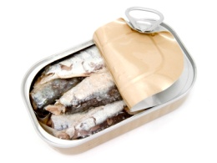
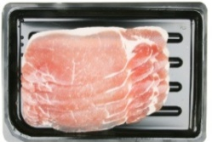
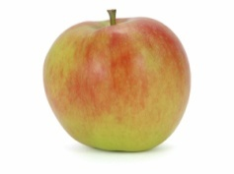

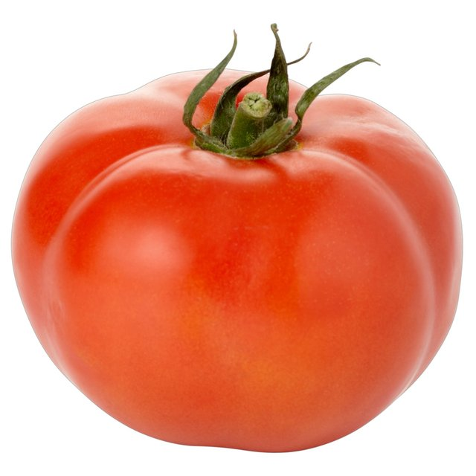
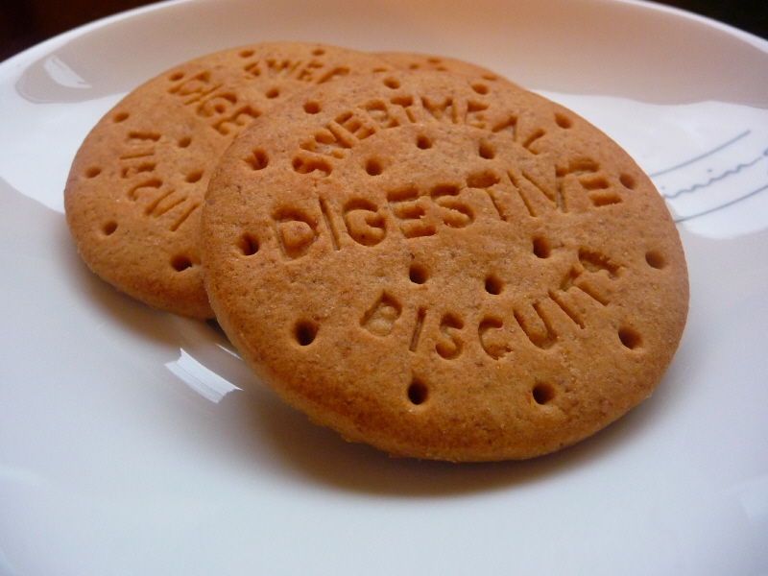
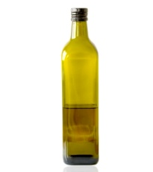
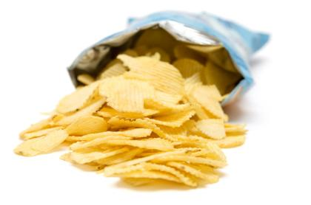
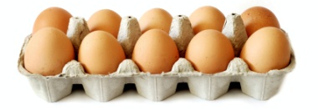
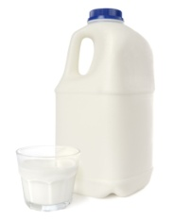
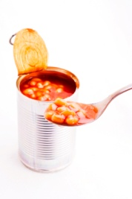
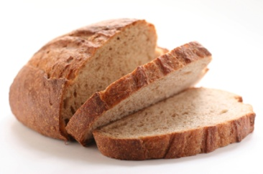
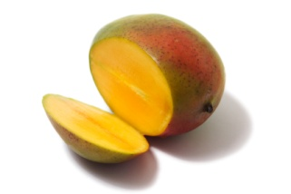
25g packet of ready salted crisps
Rank:
Cost:
1 litre bottle of olive oil
Rank:
Cost:
400g packet Digestive biscuits
Rank:
Cost:
4 pint bottle of whole milk
Rank:
Cost:
Box of 12 medium eggs
Rank:
Cost:
300g packet of bacon
Rank:
Cost:
One beef tomato
Rank:
Cost:
One mango
Rank:
Cost:
800g loaf of bread
Rank:
Cost:
420g can of baked beans
Rank:
Cost:
120g can of sardines
Rank:
Cost:
One apple
Rank:
Cost:

