Working to a budget

- Calculate the cost of the recipe below.
- Calculate the cost per portion.
- Describe how the cost of the recipe could be reduced.
- What could you add to the recipe to add another portion of vegetables per person (1 portion = 80g)?

Ingredients
450g lean beef mince
1 onion, peeled and finely chopped
2 garlic cloves, peeled and crushed
1 x 2.5cm piece fresh root ginger, peeled and finely chopped
1 x 425g can chopped tomatoes
1-2 green chillies, deseeded and finely chopped
Salt and freshly milled black pepper
10ml/2tsp garam masala
2 handfuls freshly chopped coriander

Aromatic Masala Mince
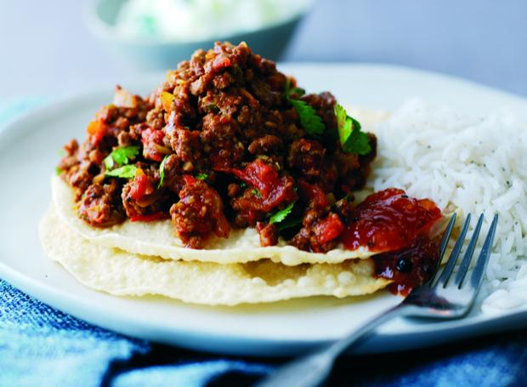

Serves: 4 Prep Time: 10 minutes Cook Time: 35 minutes

A speedy Indian recipe with beef or lamb mince, garam masala spice, chopped tomatoes, onion, garlic, ginger, chillies, chopped tomatoes and freshly chopped coriander.

Method
1. Heat a large, non-stick frying pan until hot and cook the mince, onion, garlic and ginger for 5-7 minutes.
2. Reduce the heat and add the tomatoes, chillies, seasoning, garam masala and half the coriander.
3. Bring to the boil, reduce the heat and simmer, uncovered, for 30 minutes, stirring occasionally.
4. Garnish with the remaining coriander and serve with plain basmati rice, poppadoms and a cucumber raita, or a selection of relishes.

Ingredient | Weight bought | Cost | Weight needed | Cost used
lean beef mince |  |  | 450g
onion* |  | 80p/kg | 125g
garlic cloves | 1 bulb (10 cloves) | 30p | 2 cloves
root ginger |  | £2.10/kg | 25g
can chopped tomatoes |  |  | 425g
green chillies* (2) | 50g | 65p | 30g
*Average weight

