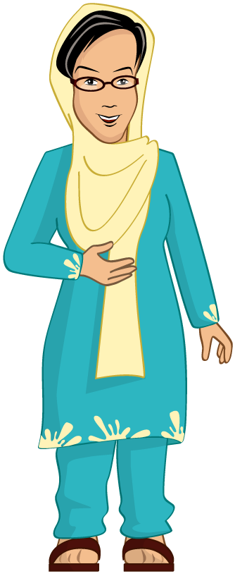
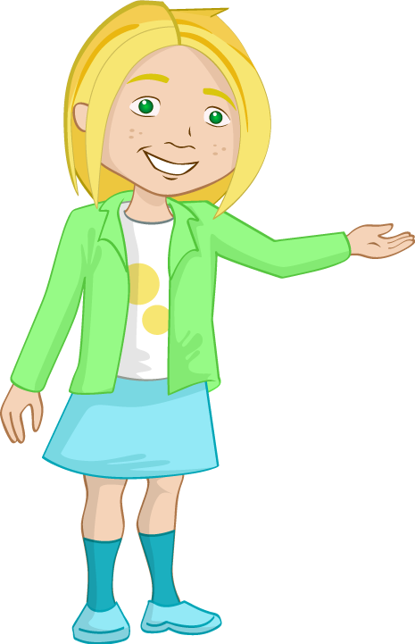
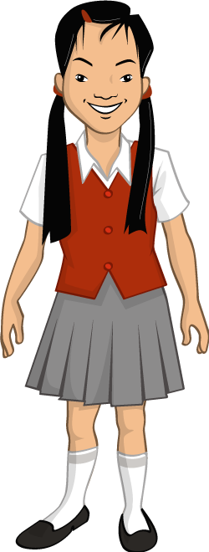
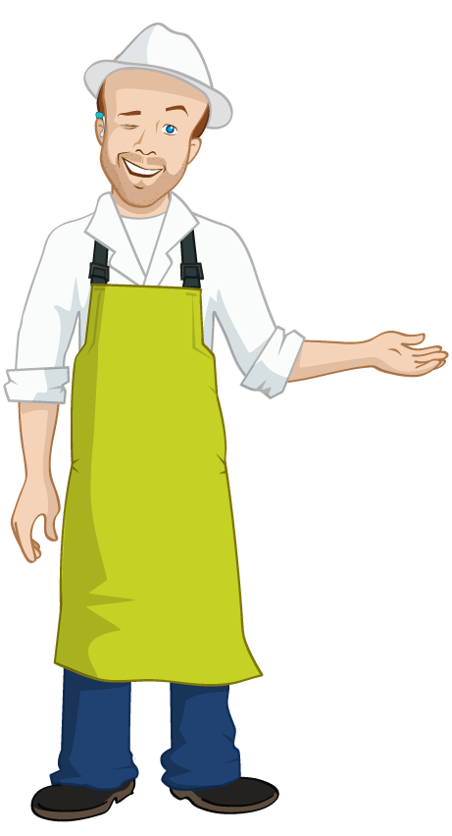
I have an allergy to cow’s milk, so I can’t have milk or anything made with milk
(like cheese).
As part of my religion, I don’t eat foods made from pork (like ham).
I eat fish but not meat.
I’m a pescatarian!
I don’t like fish but I love meat!
Nicola
Chik Chi
Ray Skate
Mrs Begum
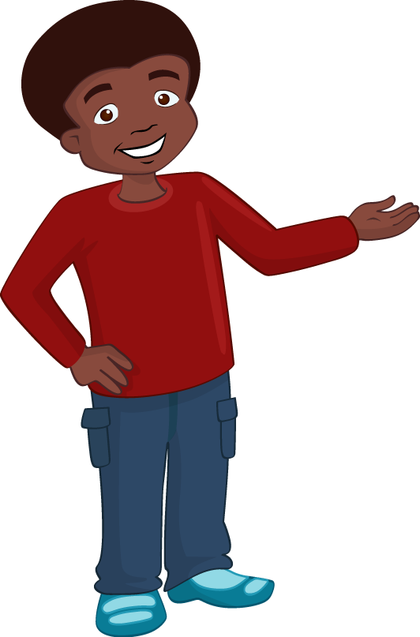
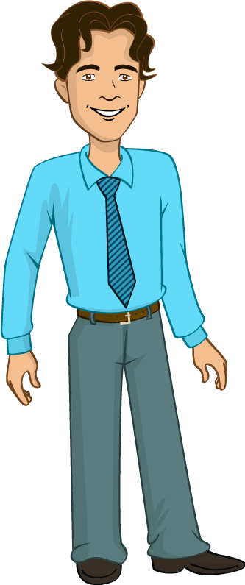
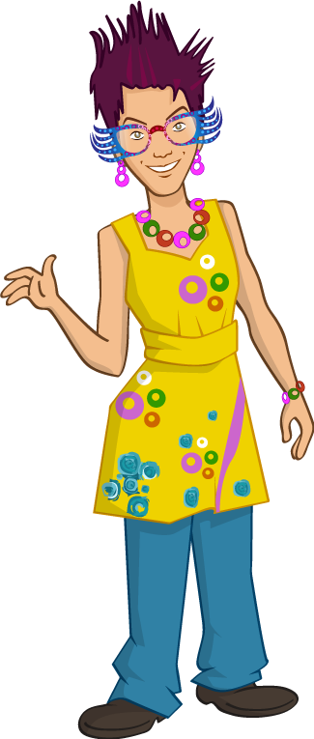
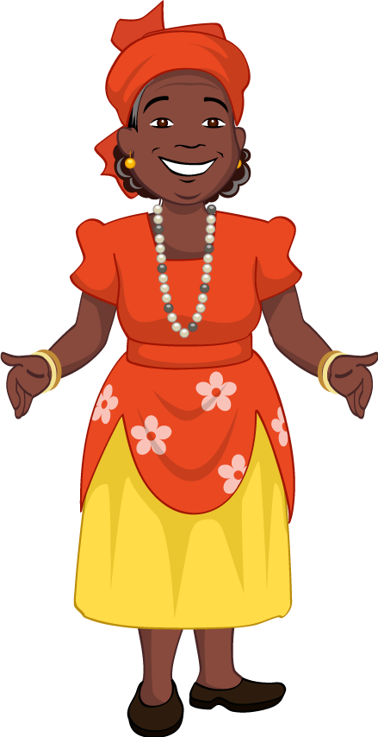
I’m a vegetarian.

I am allergic to eggs, so I can’t eat eggs or anything that has egg in it (like mayonnaise).

I can’t eat gluten. Gluten is in wheat, barley and rye, which are used to make food like bread, pasta and cakes. I have to check that food is gluten free by looking at the labels.

I’m vegan, so I don’t eat any foods that come from animals.
Frankie McKay

Mrs Bolt
Mr Valdez
Jordan

