Croque monsieur

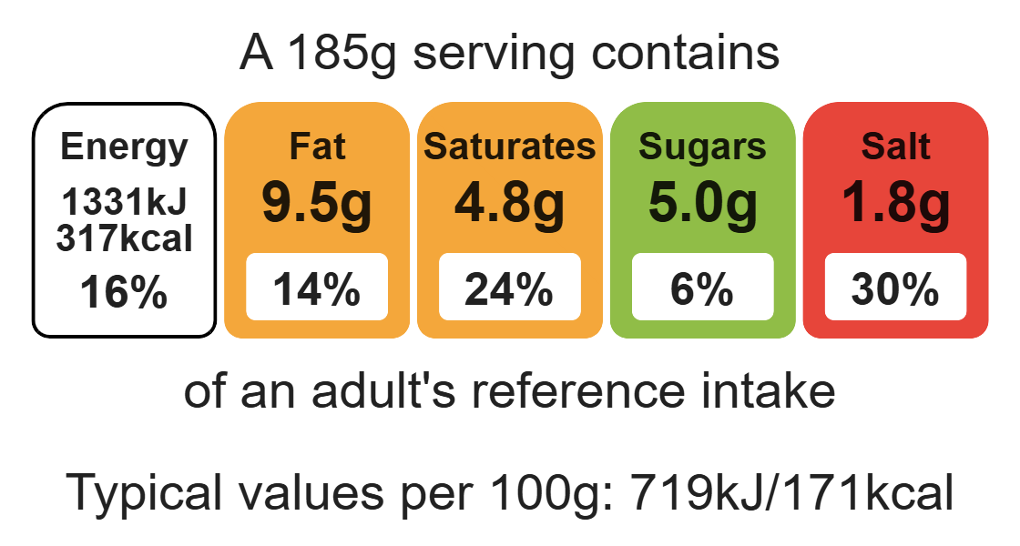

Complexity: low - medium

Ingredients (serves 1)

30g reduced-fat cheese, e.g. Cheddar

Equipment

Chopping board

Grater

Sharp knife

Fish slice

1 tomato

2 slices wholegrain bread

1 slice ham

Method
- Preheat the grill.
- Grate cheese on a chopping board – divide into 3.
- Slice the tomato.
- Place the slices of bread on the chopping board.
- Lay the ham over one slice of bread.
- Arrange the tomato over the other slice of bread.
- Sprinkle a portion of cheese over both slices of bread.
- Place the sandwich under the hot grill.
- When the cheese is melted and bubbling hot, remove from the grill.
- Press the 2 slices of bread together and sprinkle the remaining cheese on top.
- Place under the grill until the cheese is melted and golden.

Top tips
- Focus on fibre: Use different types of bread, e.g. ciabatta, bagel, wholemeal loaf. Wholemeal bread will boost the fibre content of the dish.
- Turn up the flavour: Try adding different varieties of cheese, e.g. Mozzarella, Cheddar, Edam, Brie.
- Reduce food waste: Use up any leftover vegetables e.g. mushrooms, pineapple, peppers.

Food skills
Weigh, cut, chop, slice, dice and trim, grate, grill.

